**Finding the digital evidences for planning for mass shooting using Disk Forensics**

**Digital forensics (Disk forensics)**

**CDAC, Noida**

**CYBER GYAN VIRTUAL INTERNSHIP PROGRAM**

**Submitted By:**

Arindam Das

Project Trainee, (May-June) 2024

**BONAFIDE CERTIFICATE**

This is to certify that this project report entitled “Finding the digital evidences for planning for mass shooting using Disk Forensics” submitted to CDAC Noida, is a Bonafede record of work done by Arindam Das under my supervision from 10th June 2024 to 19th July 2024

**Declaration by Author(s)**

This is to declare that this report has been written by me/us. No part of the report is plagiarized from other sources. All information included from other sources have been duly acknowledged. I/We aver that if any part of the report is found to be plagiarized, I/we are shall take full responsibility for it.

Name of Author(S): Arindam Das

**TABLE OF CONTENTS**

|  |  |  |
| --- | --- | --- |
| **Sl no.** | **Title** | **Page** |
| 1 | Introduction | 1 |
| 1.1 | Problem Addressed | 1 |
| 1.2 | Digital Forensics (Disk Forensics) | 1 |
| 1.3 | Approach | 1 |
| 2 | Implementations | 2 |
| 2.1 | Creating The Project | 2 |
| 2.2 | Finding Evidences | 7 |
| 2.3 | Attack Timeline | 16 |
| 3 | Conclusion & Recommendation | 17 |
| 4 | List of References | 18 |

**ACKNOWLEDGEMENT**

I would like to express my sincere gratitude to all those who have contributed to the completion of this project. First and foremost, I extend my thanks to Ms. Kajal Kashyap for their invaluable guidance and support throughout the project. Their expertise and encouragement have been instrumental in shaping the direction and quality of this work.

I am also grateful to CDAC, Noida for providing the necessary resources and facilities that made this project possible. The access to Basic Labs and Advanced Labs has significantly enriched the research and development process.

Thank you all for your contributions and support.

Sincerely,

Arindam Das

**1 INTRODUCTION**

**Finding the digital evidences for planning for mass shooting using Disk Forensics**

**1.1 PROBLEM ADDRESSED**

The 2018 Lone Wolf scenario is a set of materials from a fictional seizure of a laptop of a fictional individual who was planning a mass shooting. In the scenario, the individual’s brother alerted the police regarding the increasingly concerning behaviour of his brother. As a result of the alert, the police seized the brother’s laptop. The laptop was then imaged with the FTK Imager program and finding the digital evidences for planning for mass shooting using Disk Forensics.

**1.2 DIGITAL FORENSICS (DISK FORENSICS)**

Disk forensics, also known as computer or digital forensics, is a branch of forensic science that focuses on the collection, preservation, analysis, and interpretation of digital data stored on computer storage devices, such as hard disk drives (HDDs), solid-state drives (SSDs), and other media.

The primary goal of disk forensics is to investigate and gather evidence related to computer crimes or incidents. It involves the systematic examination of digital storage media to recover, analyze, and interpret data that may be relevant to a legal investigation or an organization's internal investigation

**1.3 APPROACH**

Tools and resources that I used to complete this project are as follows:

* **Autopsy:** Autopsy is computer software that makes it simpler to deploy many of the open-source programs and plugins used in The Sleuth Kit. The graphical user interface displays the results from the forensic search of the underlying volume, making it easier for investigators to flag pertinent sections of data.
* **FTK Imager:** This tool saves an image of a hard disk in one file or in segments that may be later on reconstructed. It calculates MD5 and SHA1 hash values and can verify the integrity of the data imaged is consistent with the created forensic image. The forensic image can be saved in several formats, including DD/raw, E01, and AD1.
* **Disk Images:** 2018 LoneWolf Scenario disk images downloaded from digital corpora website

**2 IMPLEMENTATIONS:**

**2.1 CREATING THE PROJECT:**

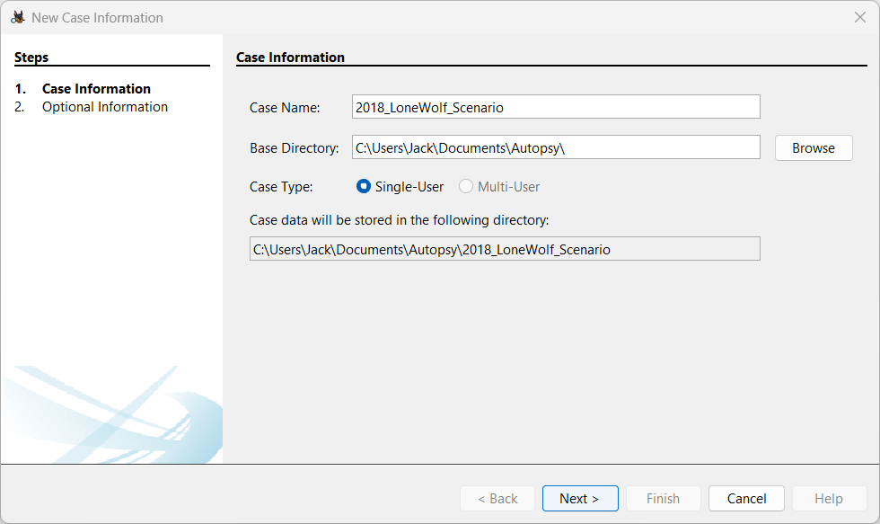The basic steps that are followed to create a new project are as follows:

First case name and location of the project has been given.

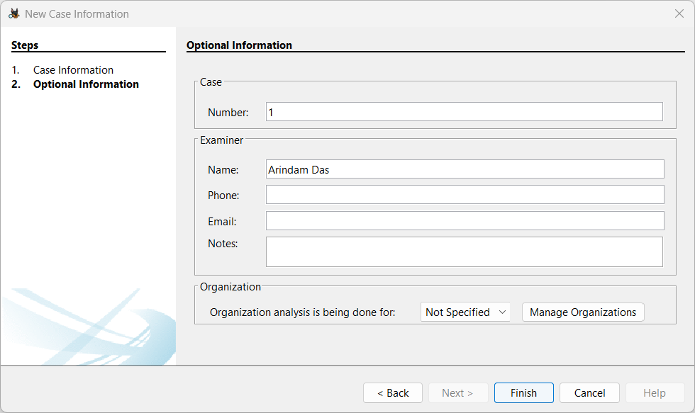

Case number and the list of examiners are added.

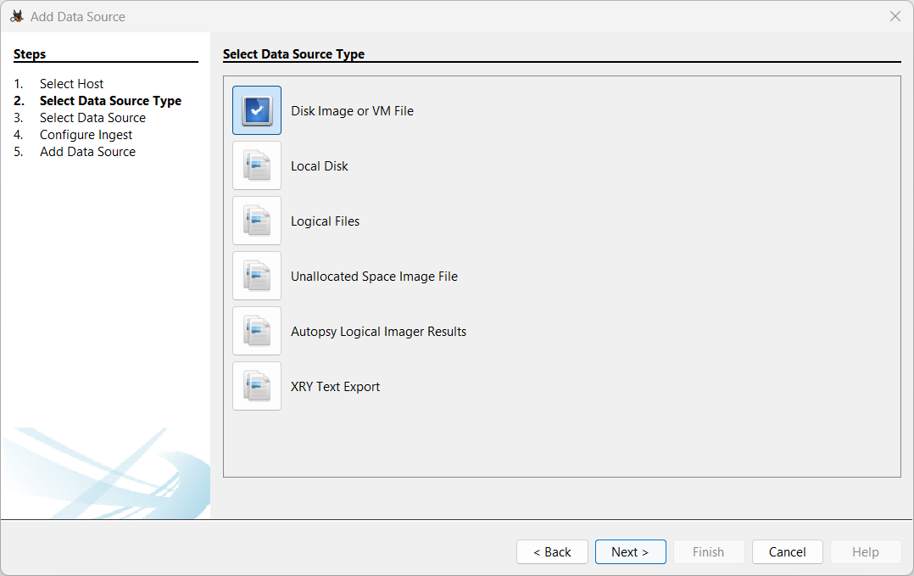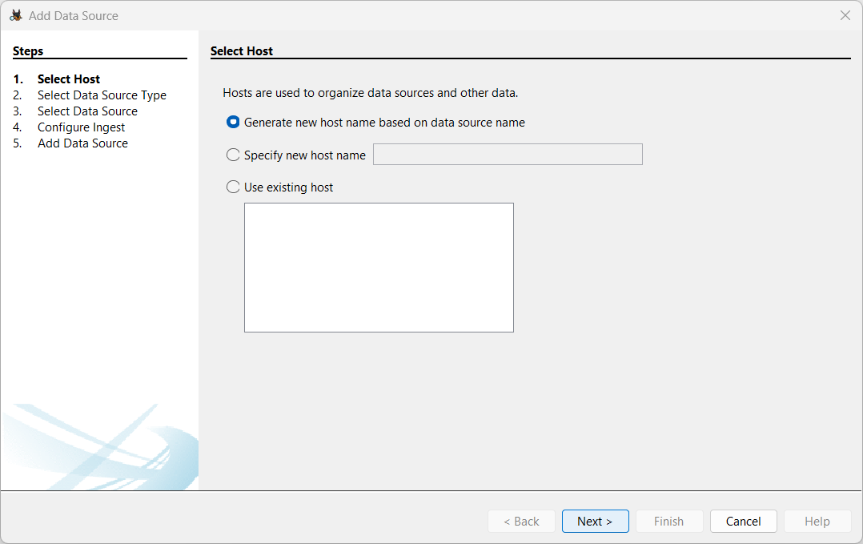A new host has been selected and data source type has been selected as Disk Image or VM File because we downloaded the image file from digital corpora website which already imaged using FTK Imager software.

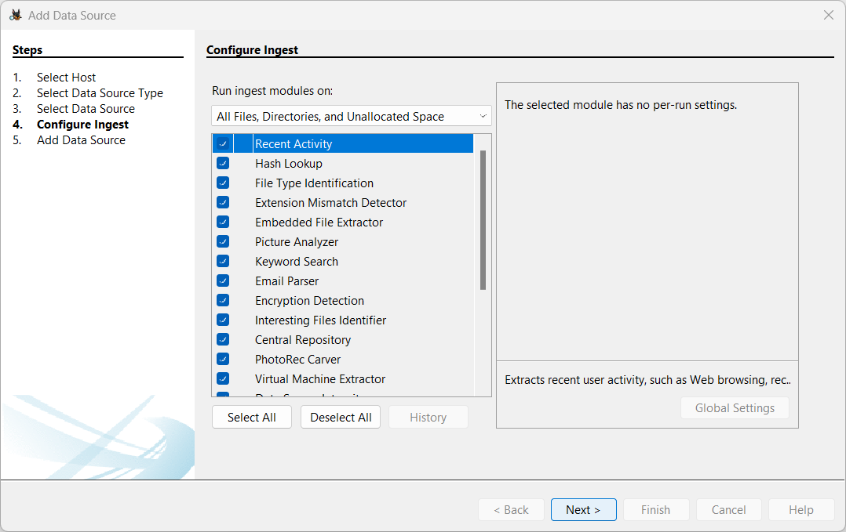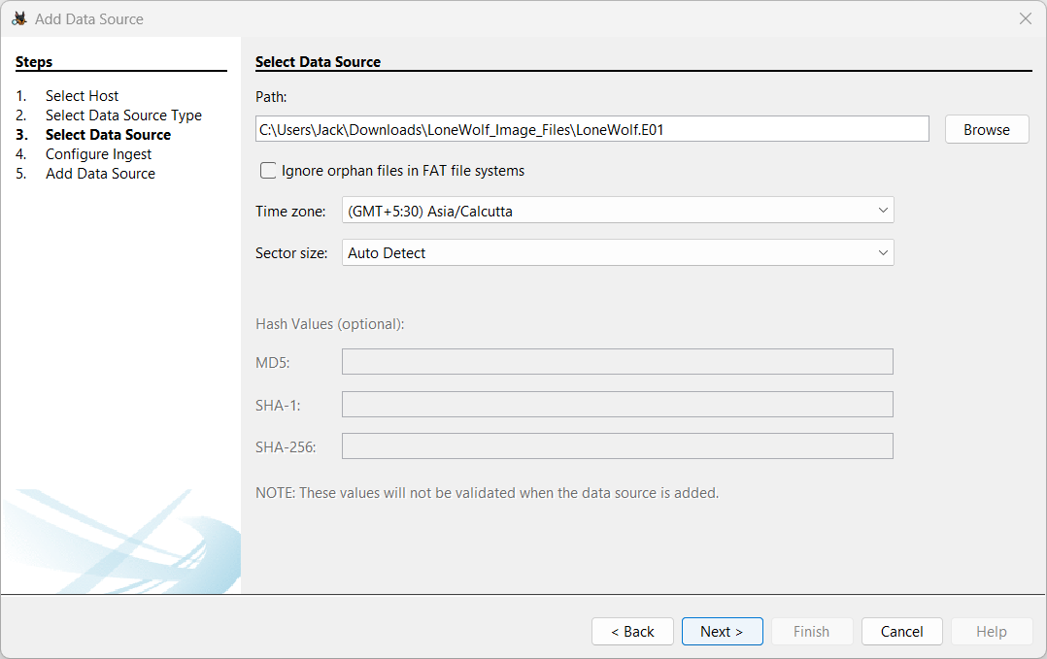Data source selected as all the downloaded disk image files.

Modules such as recent activity, hash lookup, file type identification, web searches, web history etc. are selected that would analyse our disk images for potential evidences.

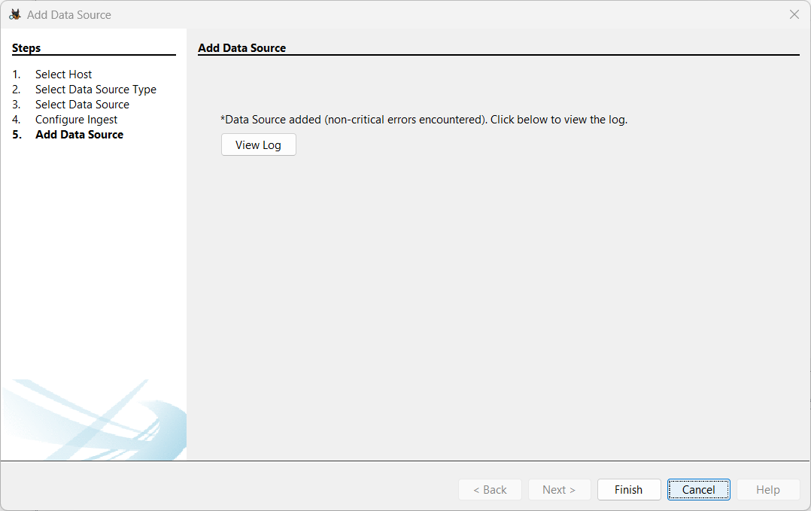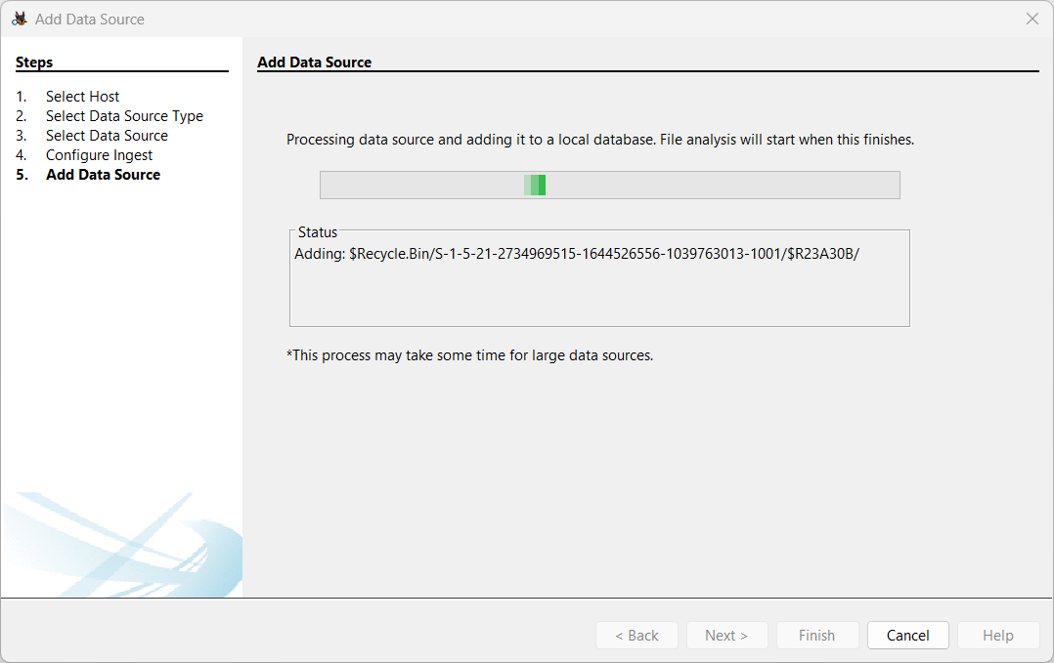The disk images are being analysed.

The data sources are added.

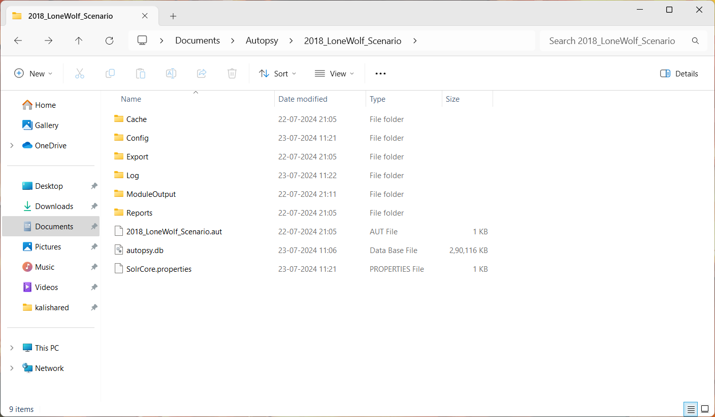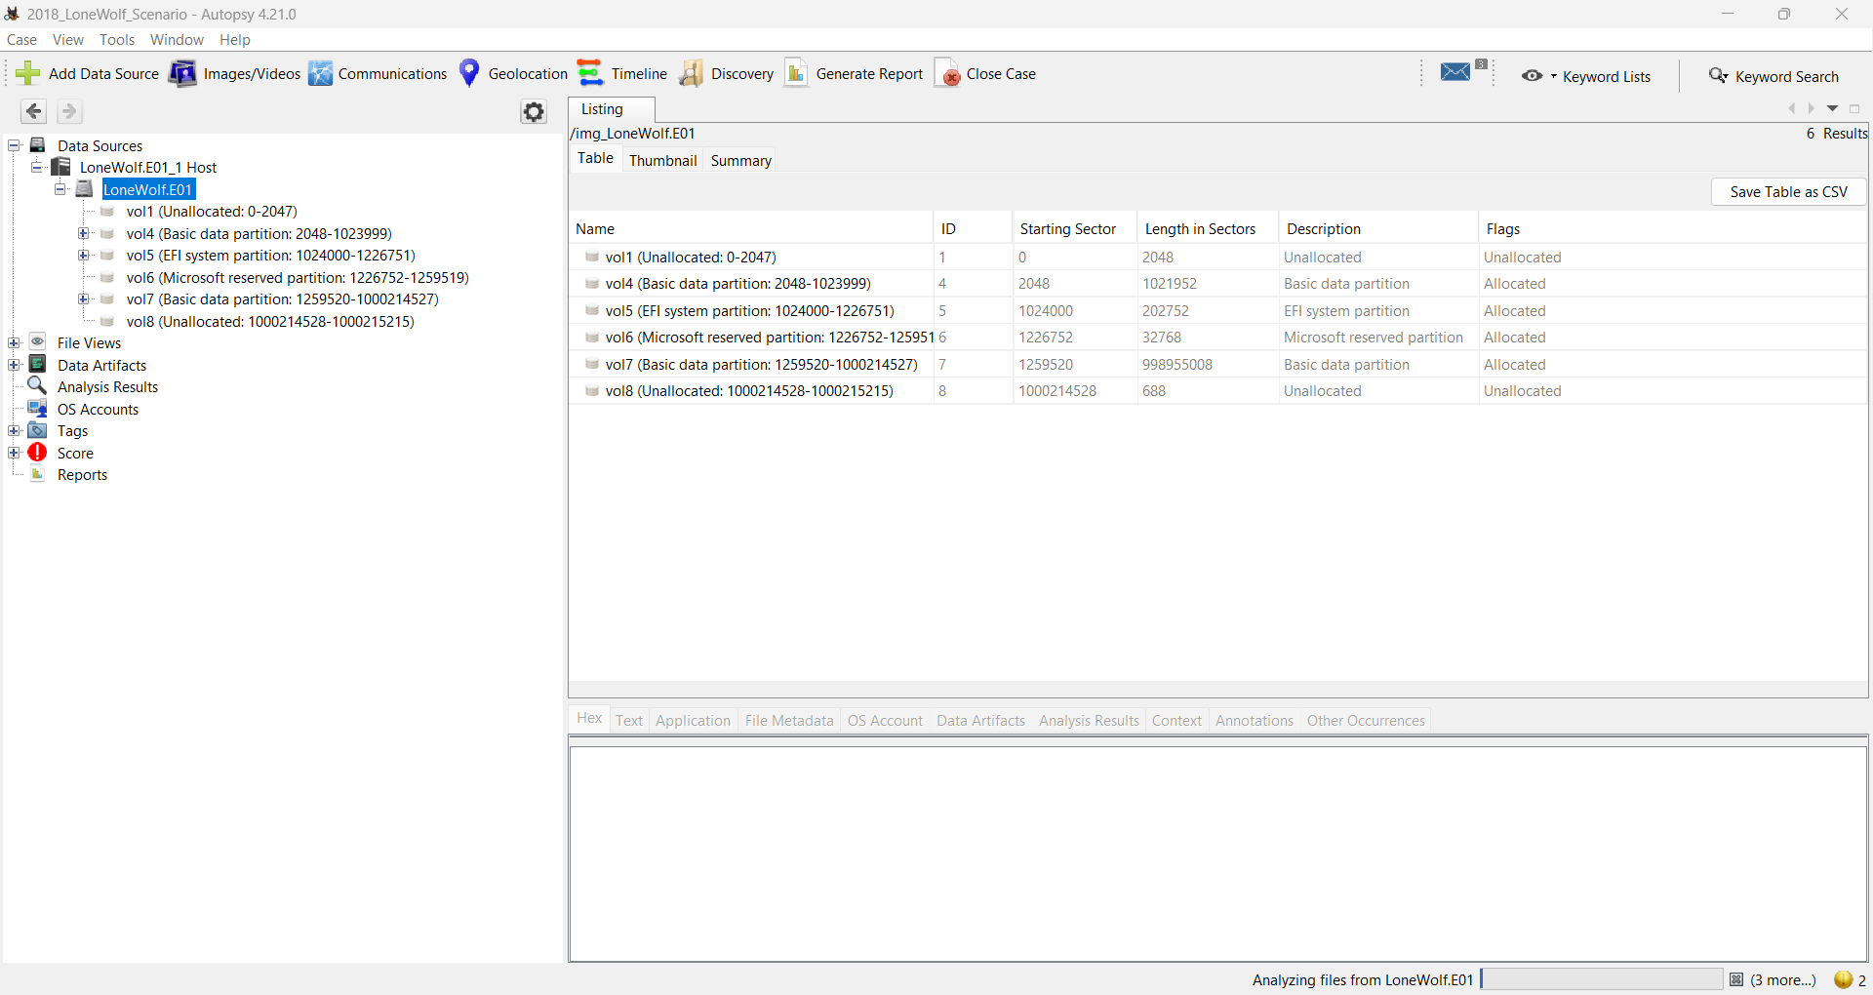The file lists and results of the modules are shown in this window.

The project location has been populated by these files.

**2.2 FINDING EVIDENCES**

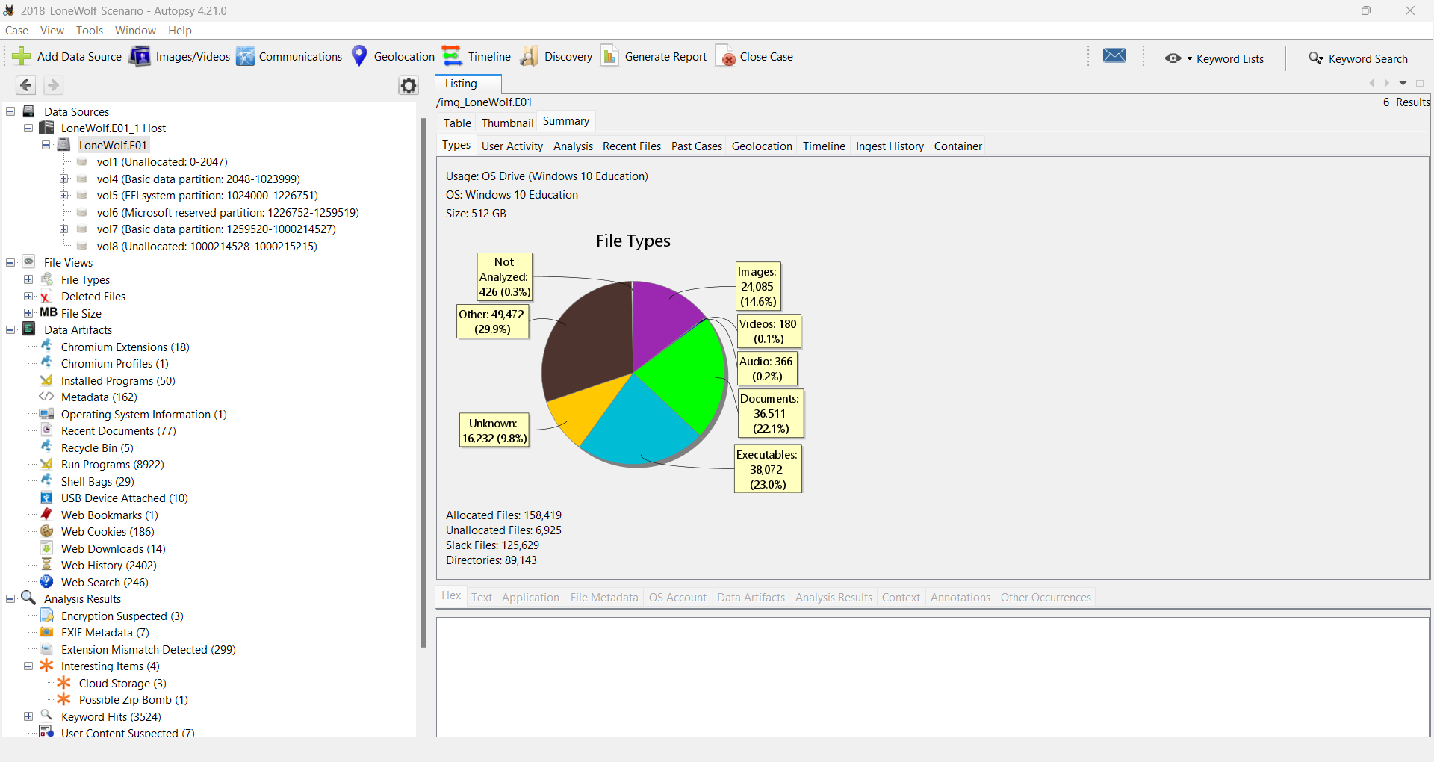After analysing the disk images I found out that there are six vloumes in the disk. On the summary tab we can see the different number of files categorized according to their file type in the pie chart. It also shows total number of allocated, unallocated and directories present in the disk.

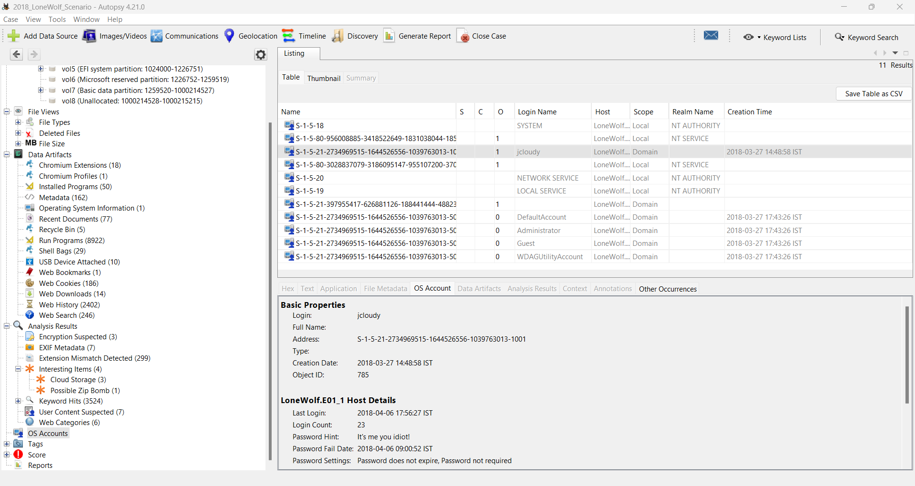The photo in the left shows different results found according to the modules that we have used. Different modules have different result sections, by clicking on each of the options we can see their results. These results are exported in CSV format and can be accessed from the export folder.



After clicking on OS Accounts section, we see the list of different users present on the system and out of all of these “jcloudy” is different because it has a password hint and it is enabled in the system. Other accounts are disabled and are not of our interest.

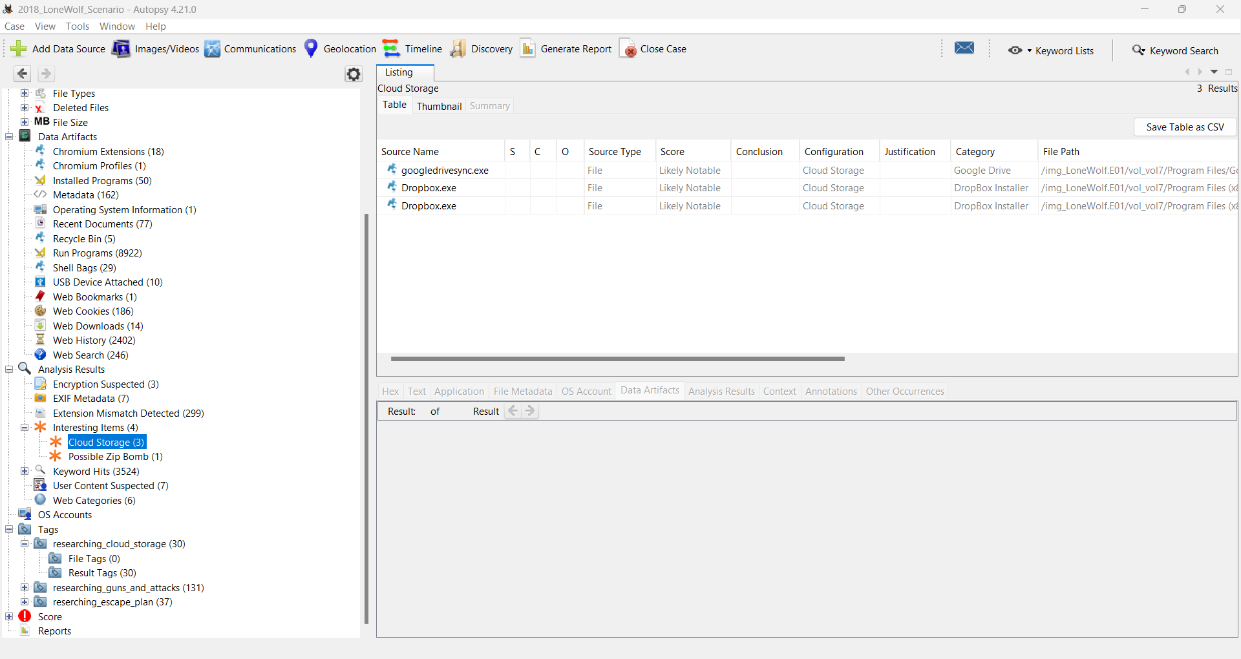

I also found that there are three cloud storage solutions present in the system.

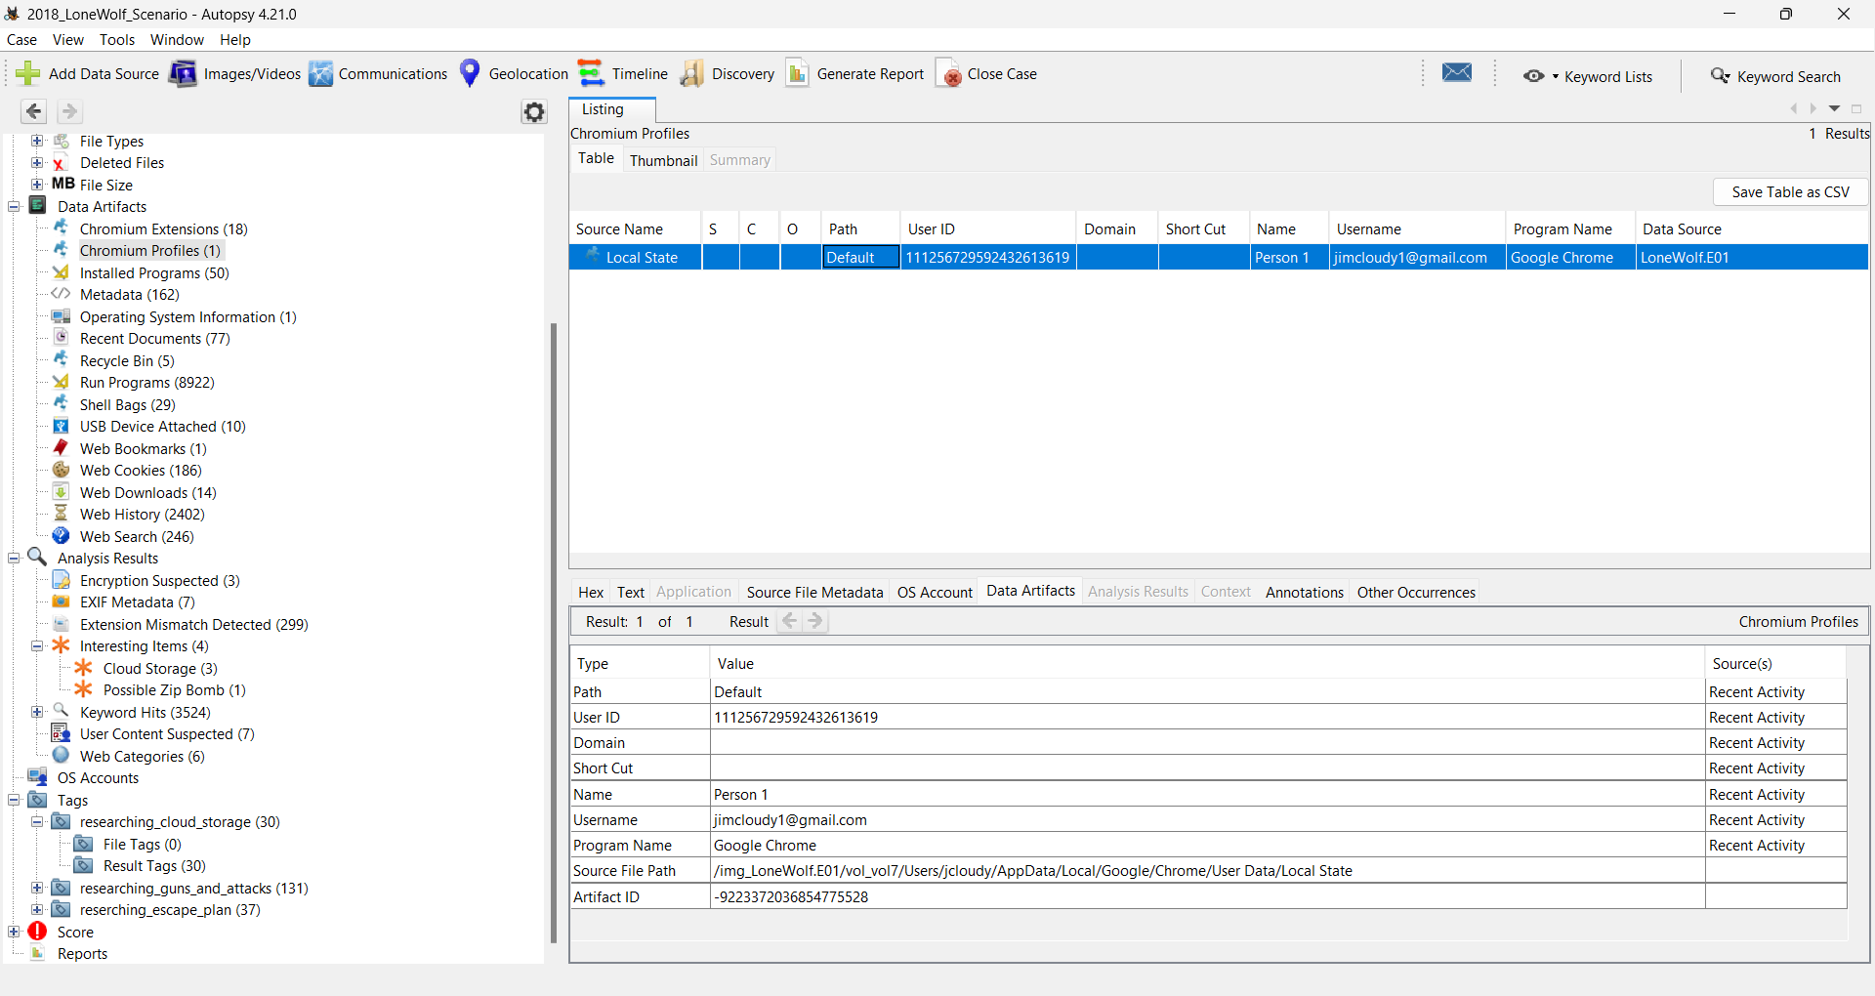

After analysing the chrome profile we can see that there is a profile with gmail account [jimcloudy1@gmail.com](mailto:jimcloudy1@gmail.com) is present. This could lead us to users web searches and web history etc. from there we can get to know what is he upto.

After this I started to analyse his web search history and found the following results (here some of the screenshots are available to see full history, anyone can check “Web Search 20240723012021.csv” from the Export folder):

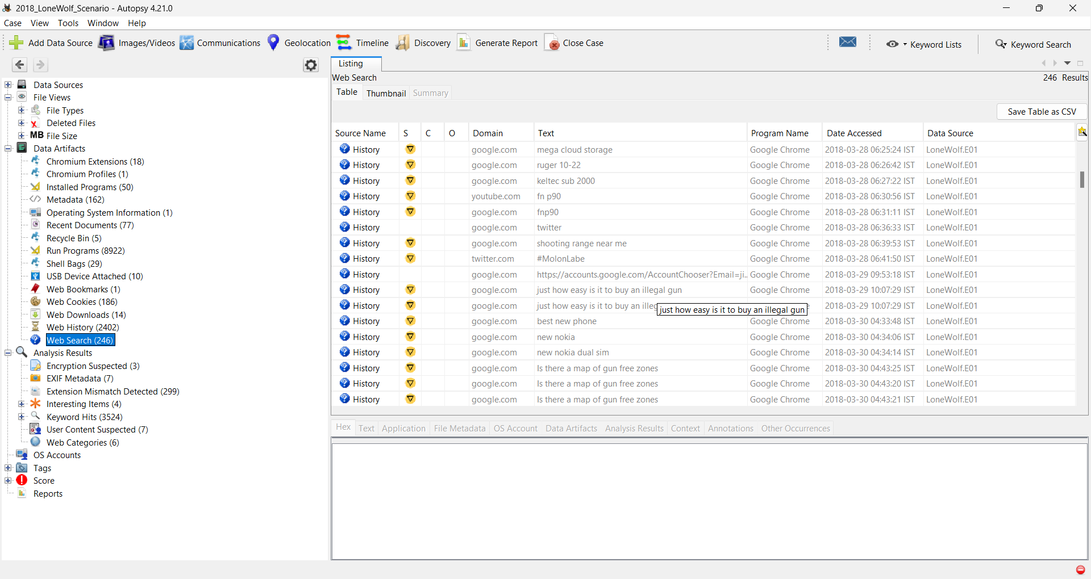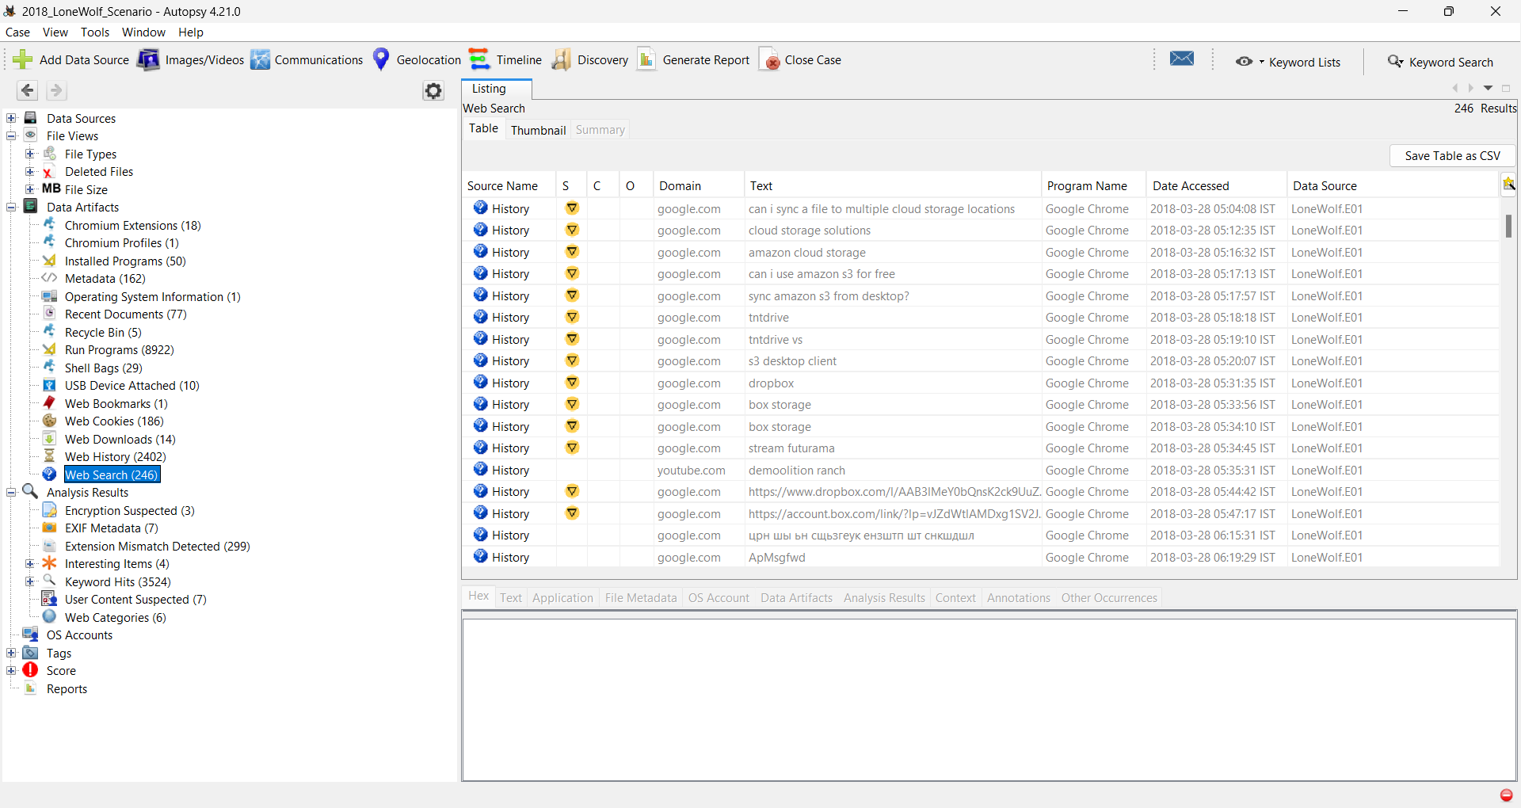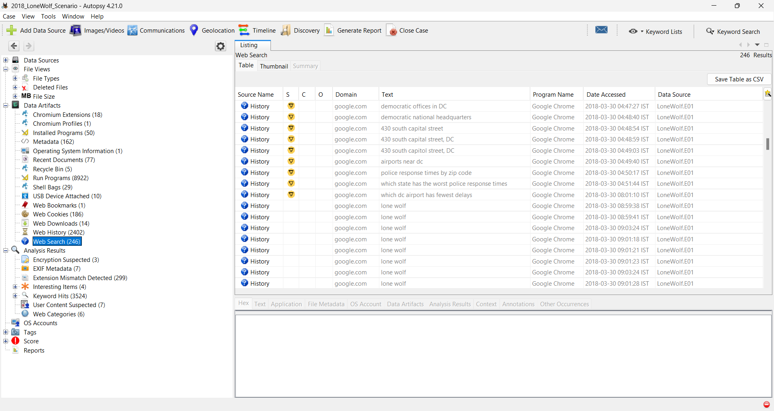

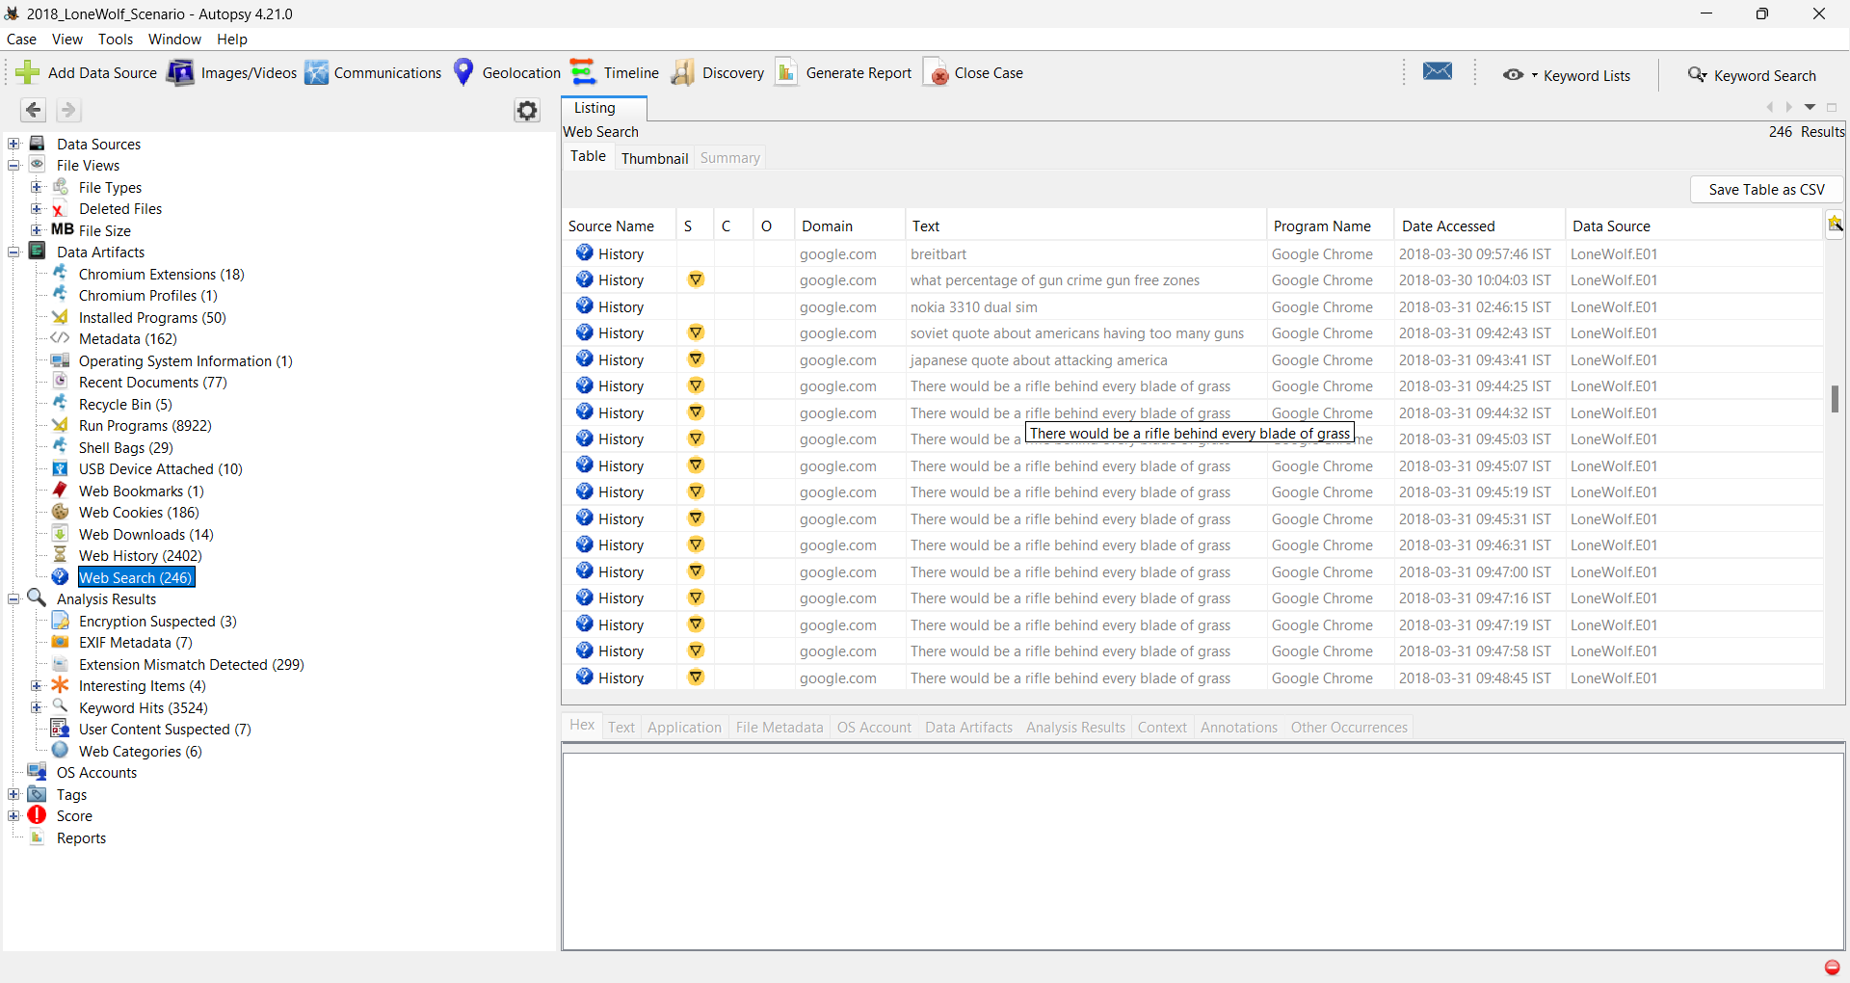

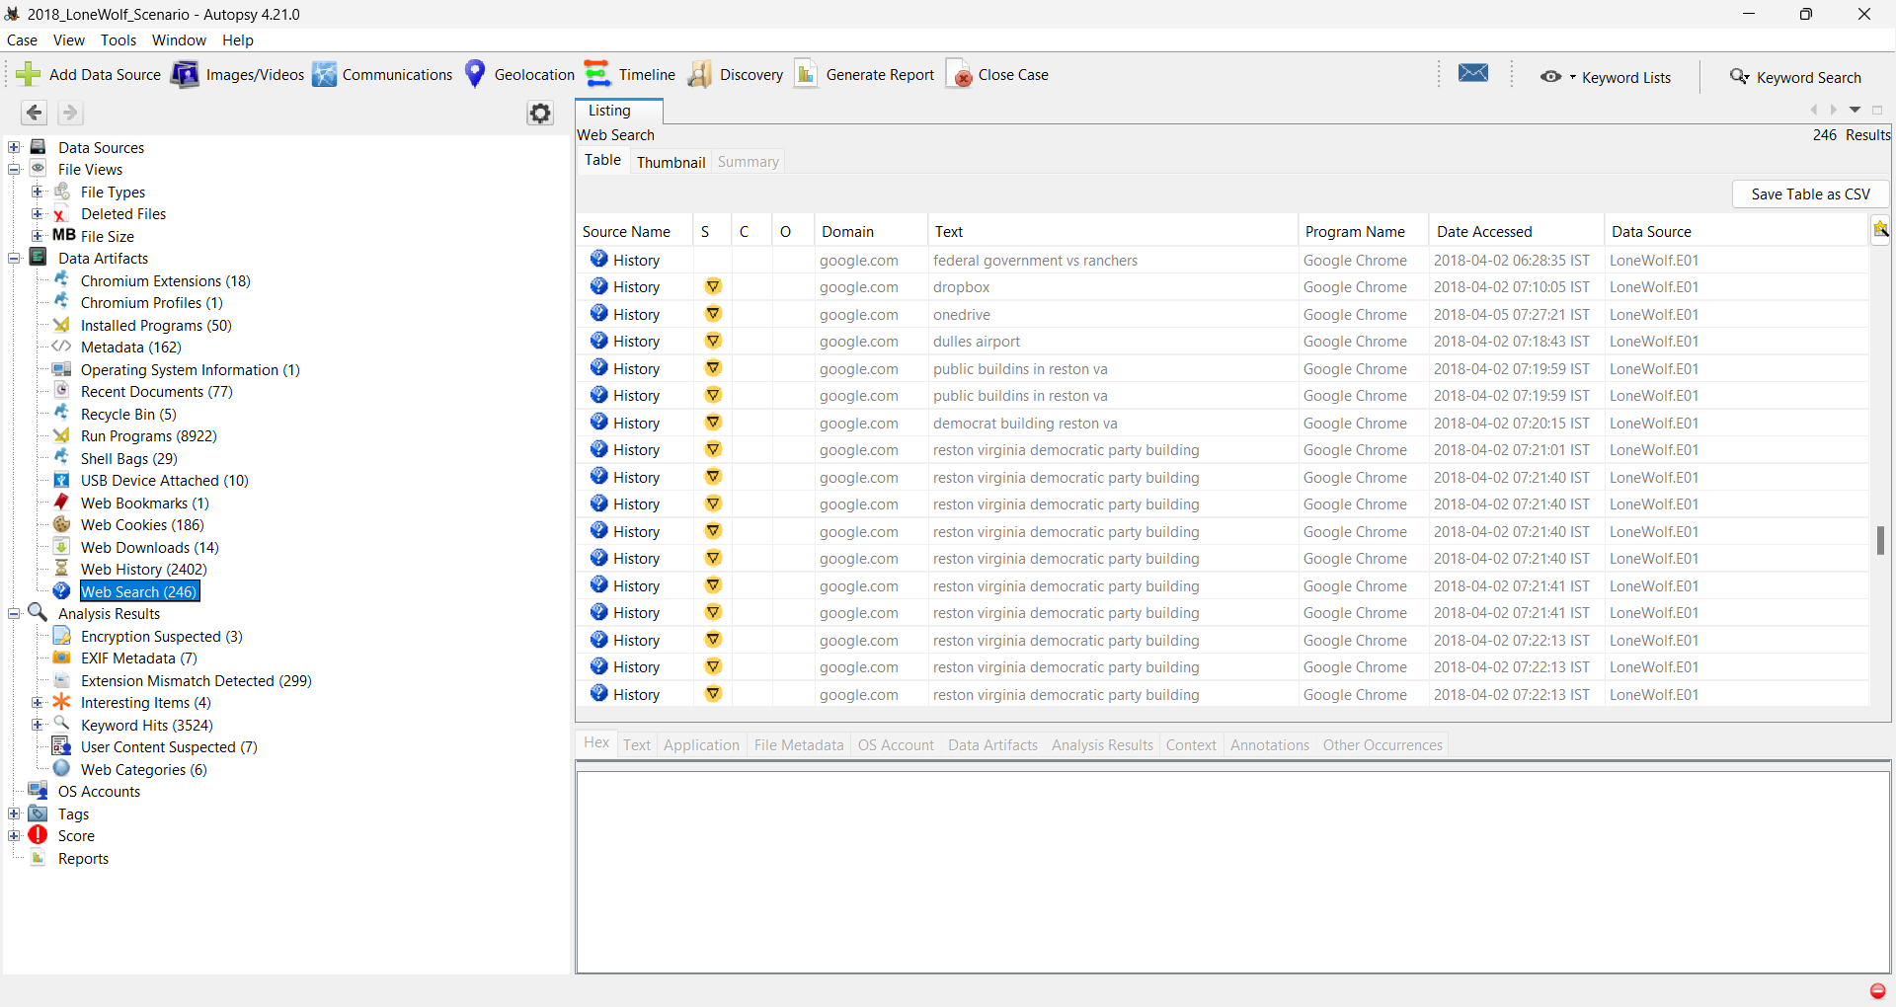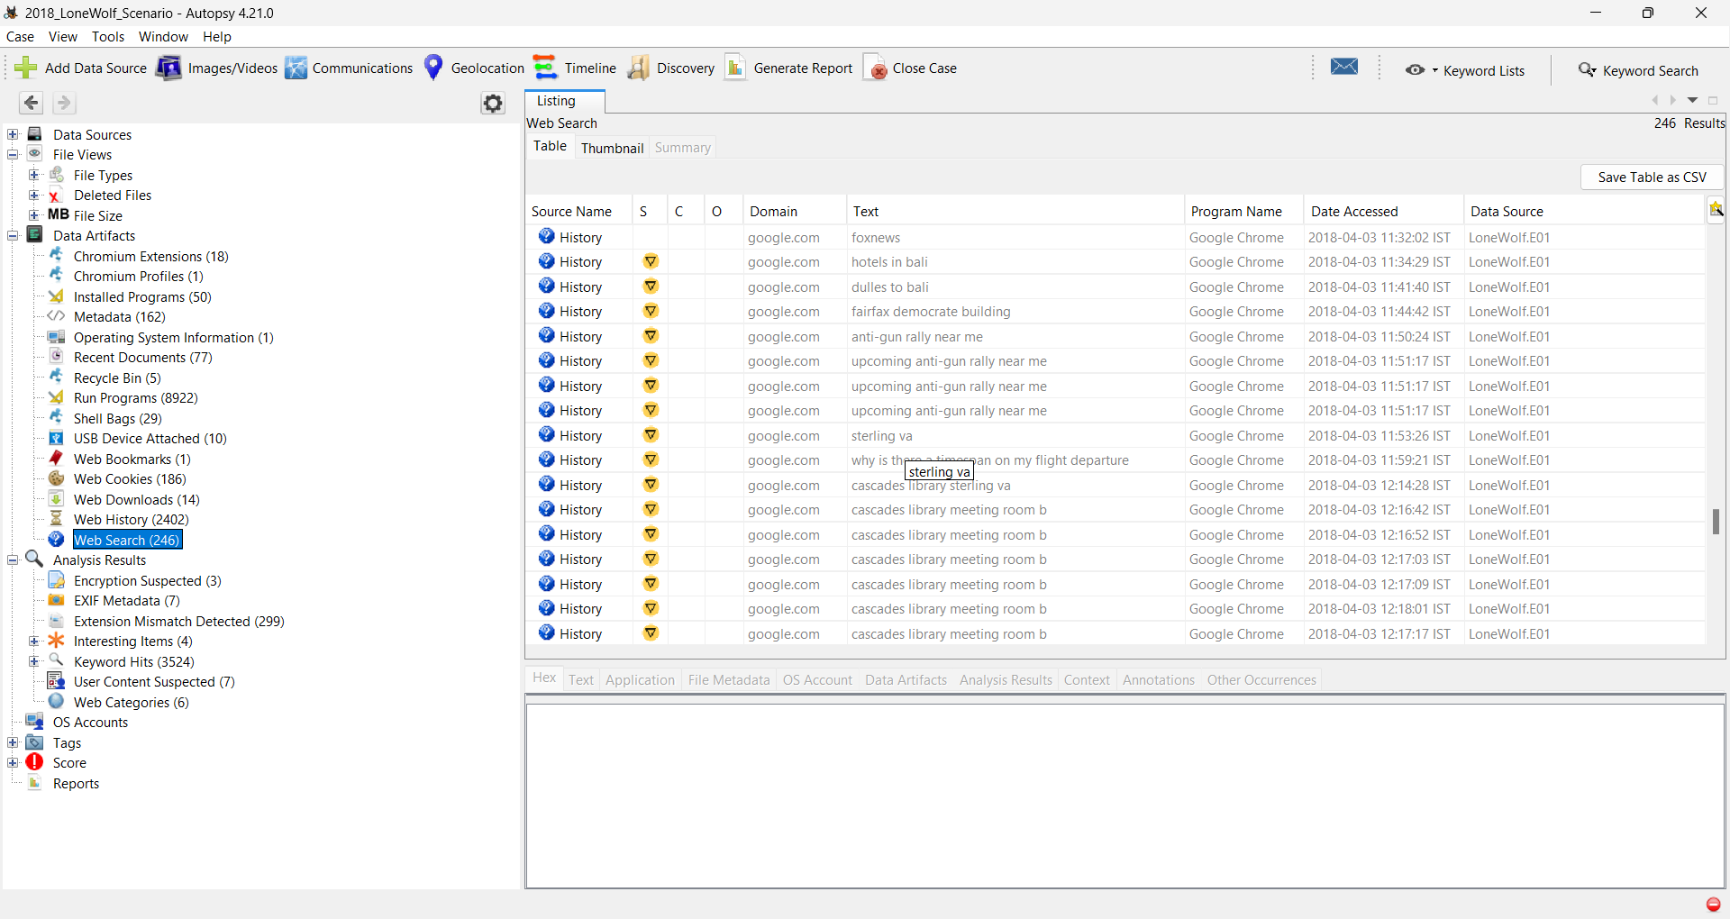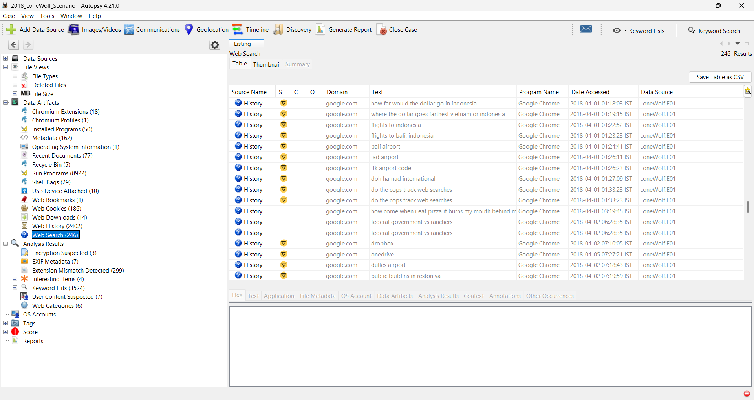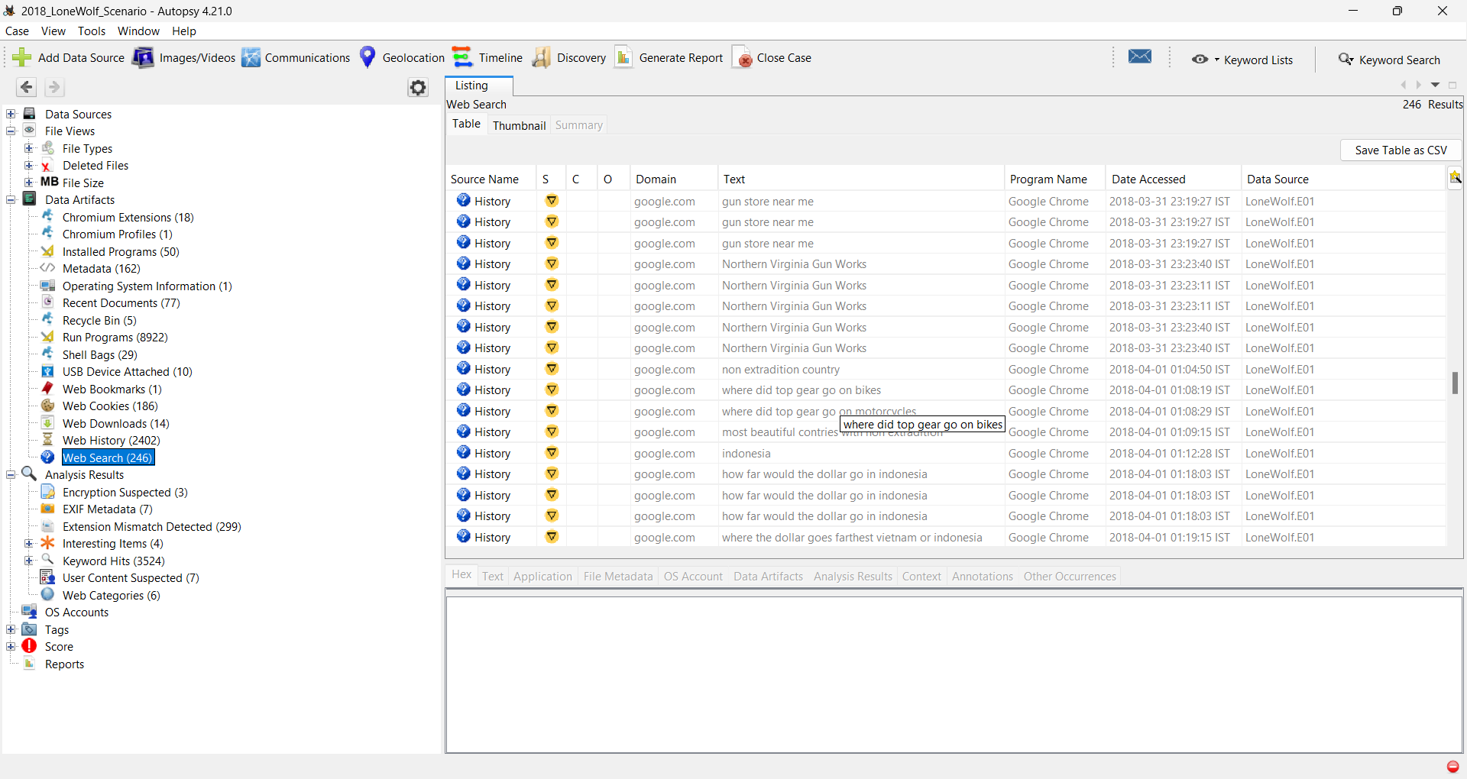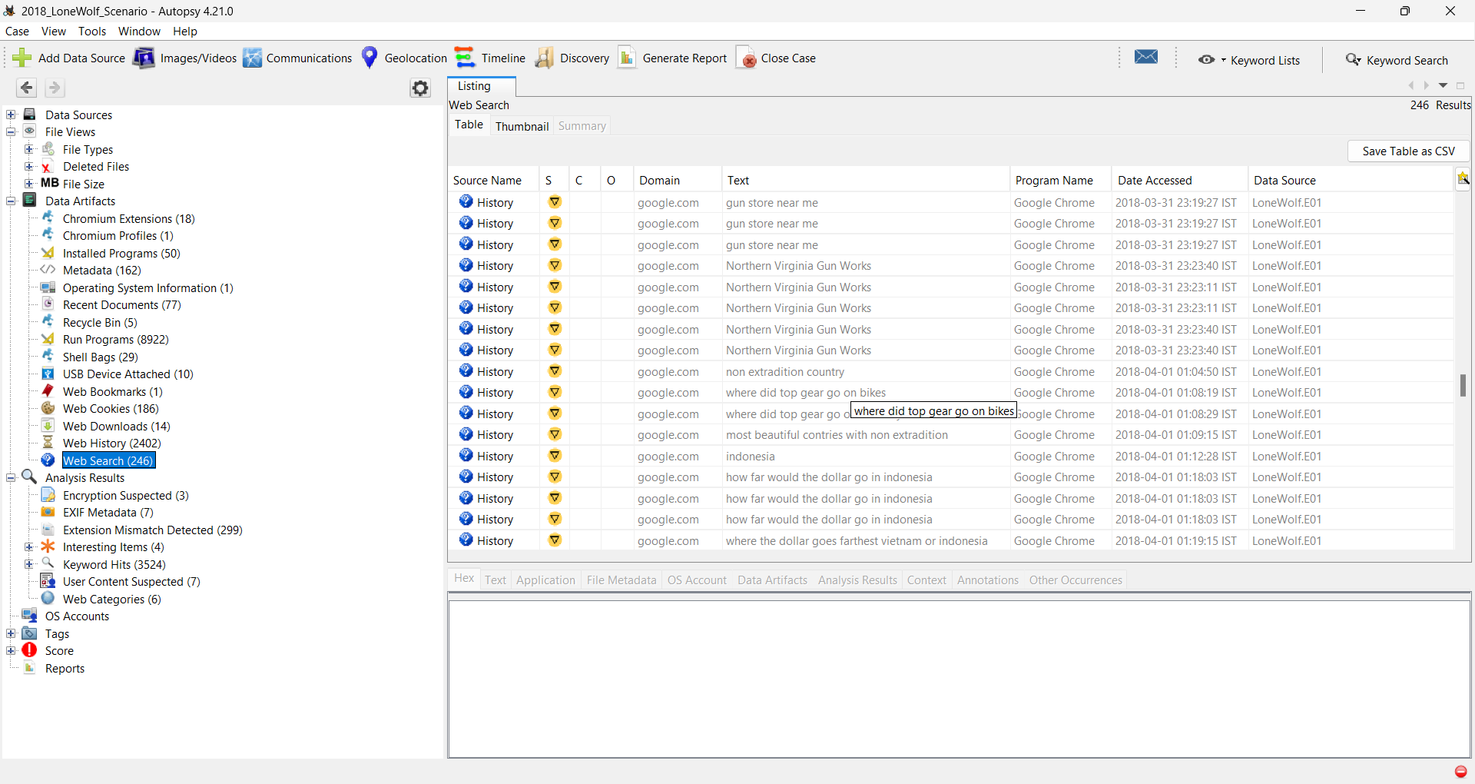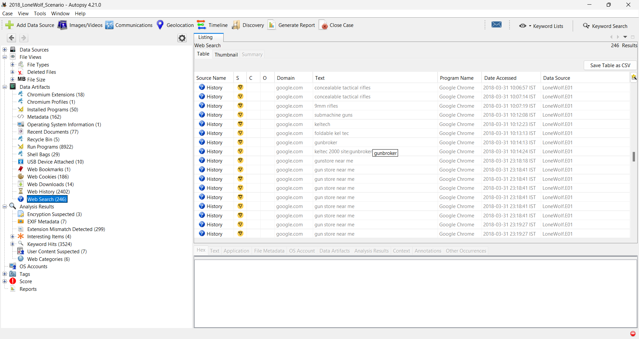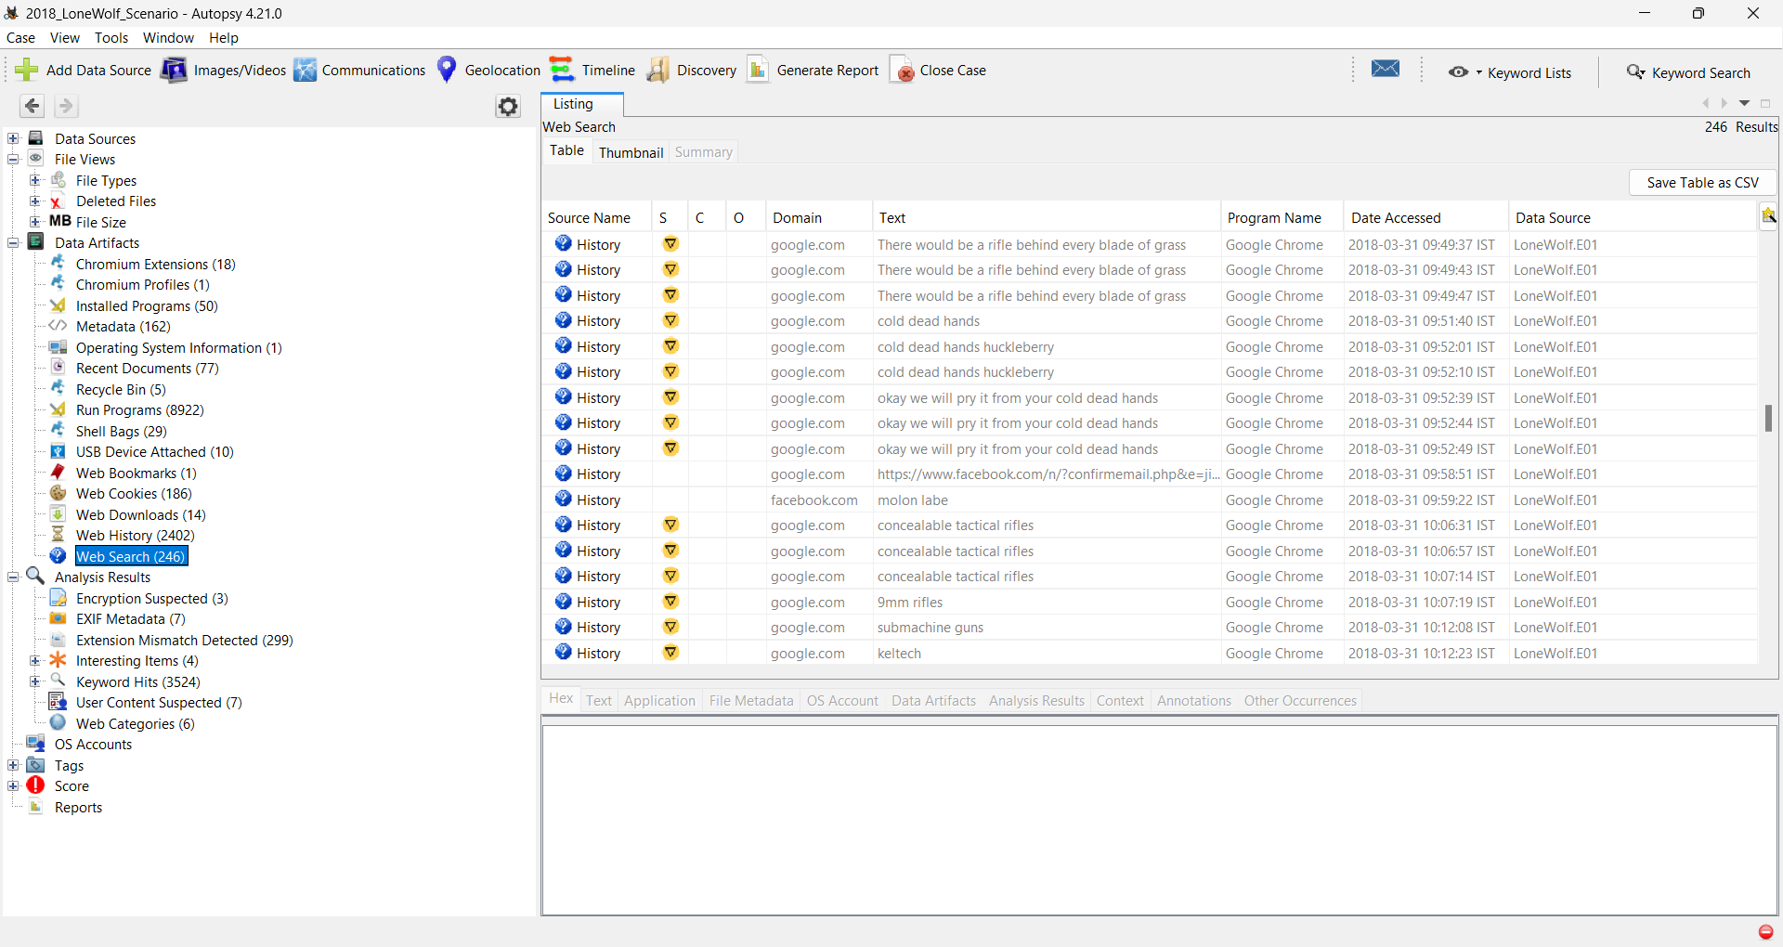

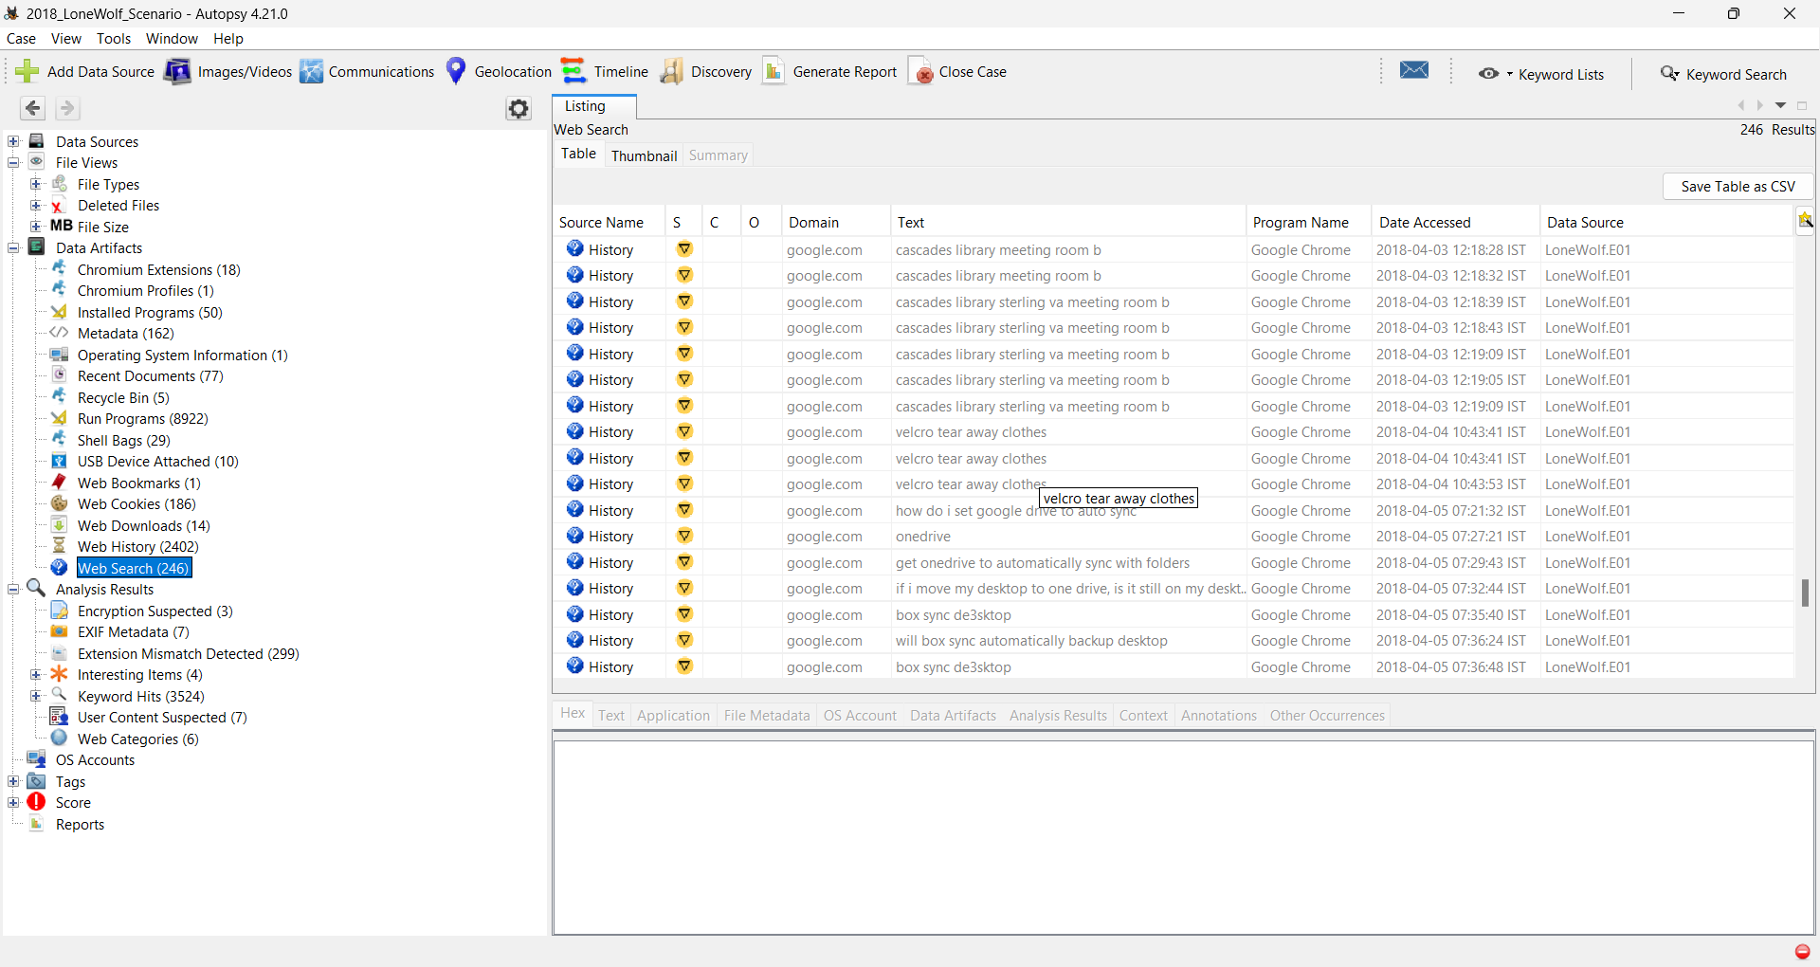

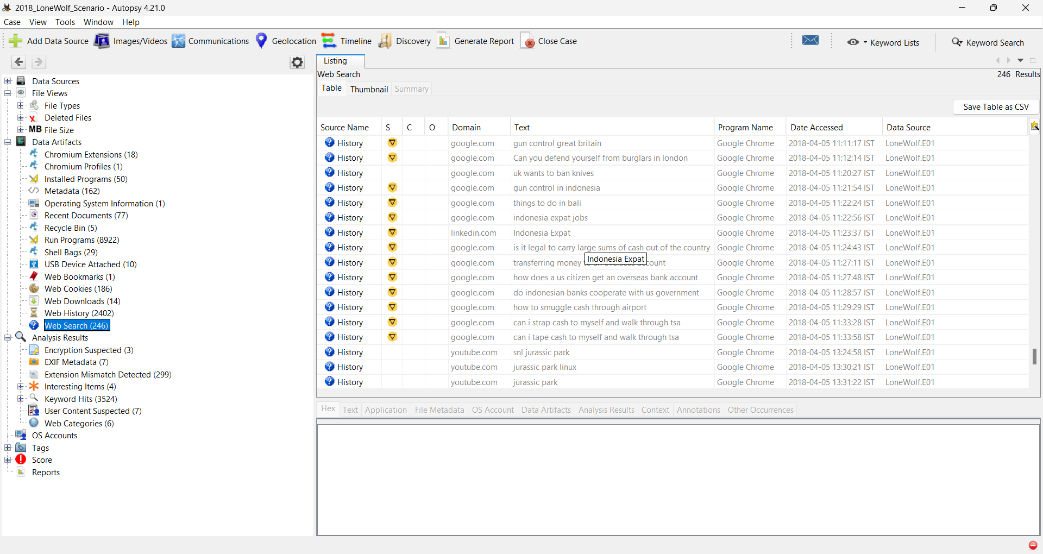

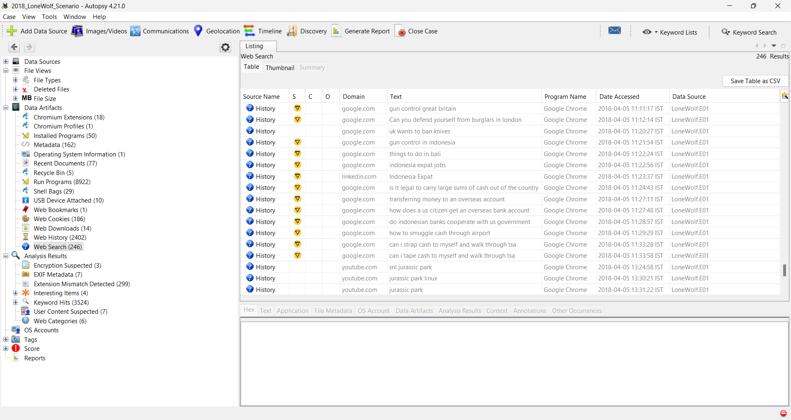

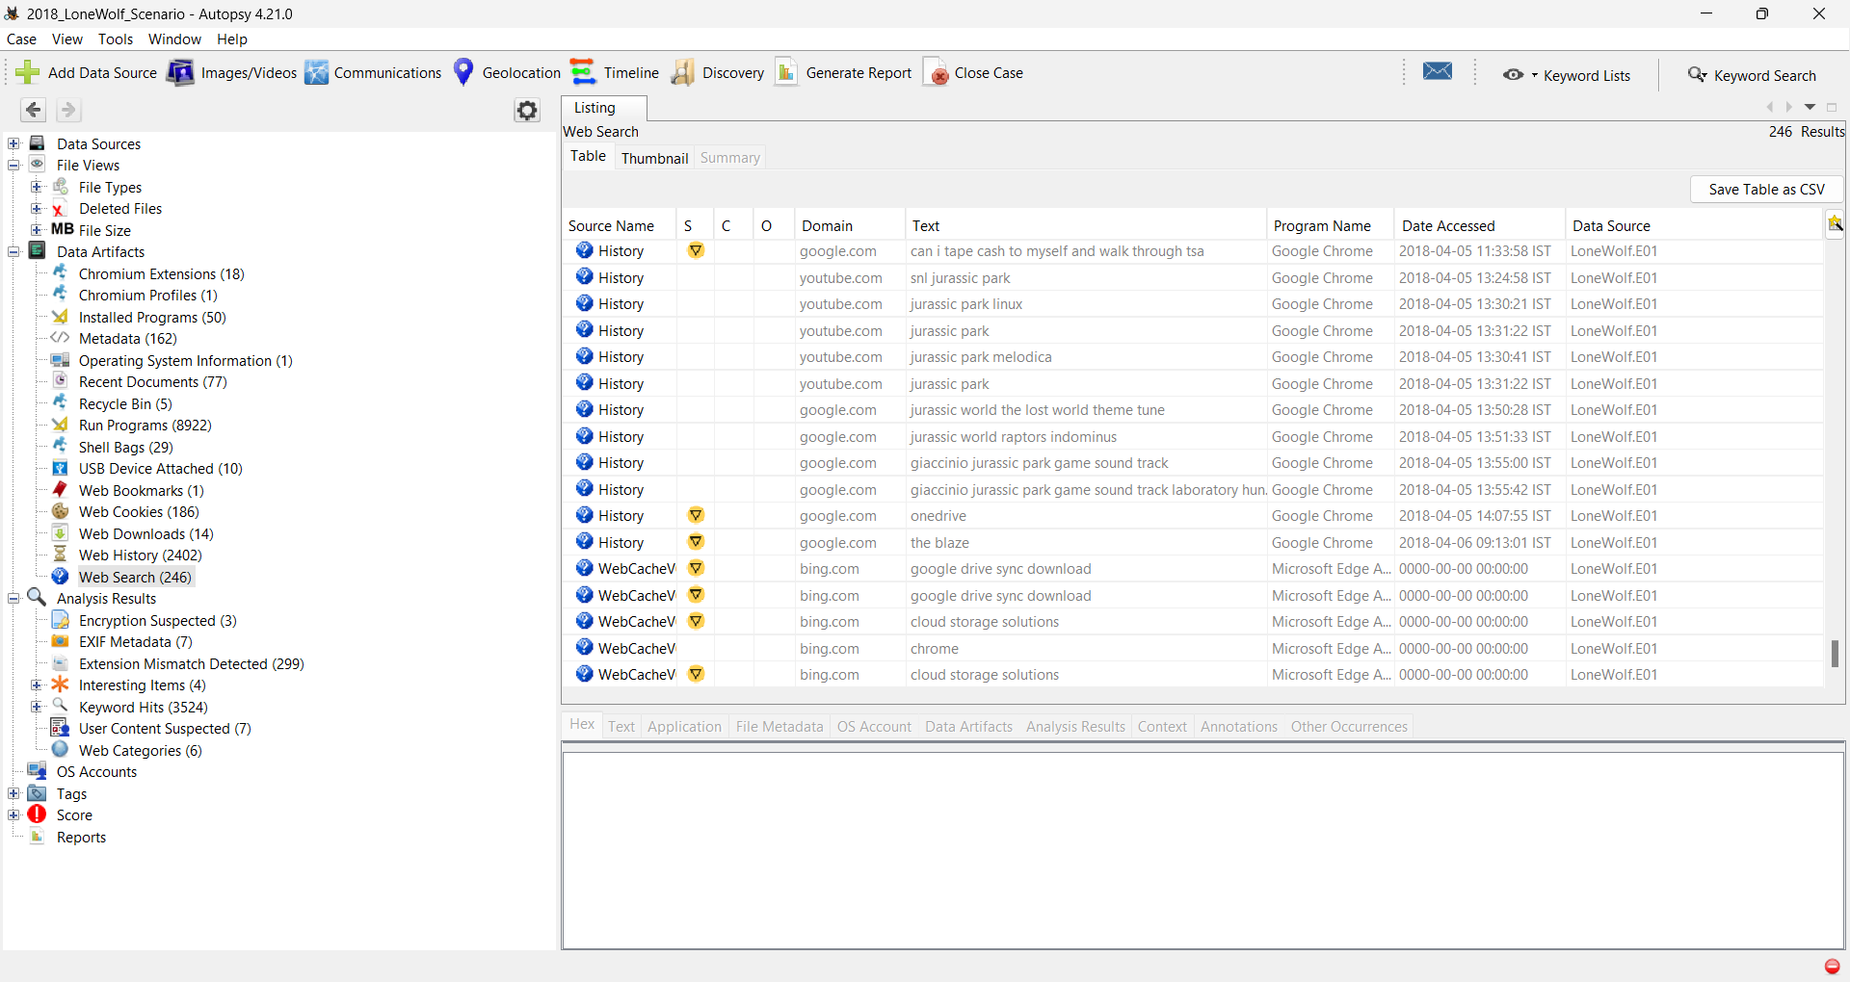After analysing his web history I found out that he was searching about cloud storages, buying illegal guns, buying a new phone, shooting ranges, hate speeches against US, meeting rooms, Indonesia, airports, money, delay in flights, police response time etc. from 2018-03-28 to 2018-04-05

Then I searched in the user folder of “jcloudy” for evidences, where I found the “Box Sync”, “Dropbox”, “Google Drive” and “OneDrive” folder and also, I searched the “Desktop” and “Downloads” folders for finding more evidence.

From there I found the following files (all file list is exported to CSV files present in Export folder with their respected names),

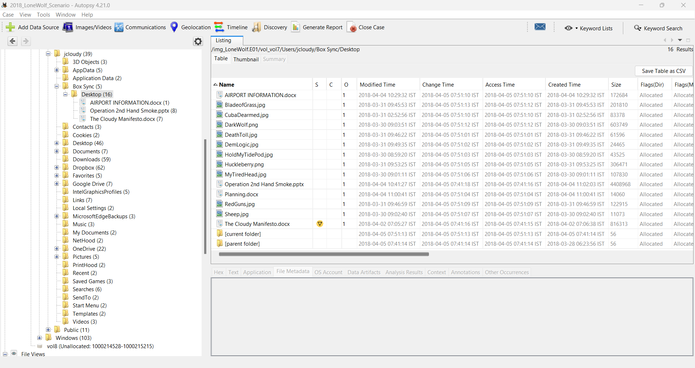Box Sync contents

“AIRPORT INFORMATION.docx”, “Operation 2nd Hand Smoke.pptx”, “Planning.docx”, and “The Cloudy Manifesto.docx” are the common files present in all the cloud storage folders and Desktop folder also.

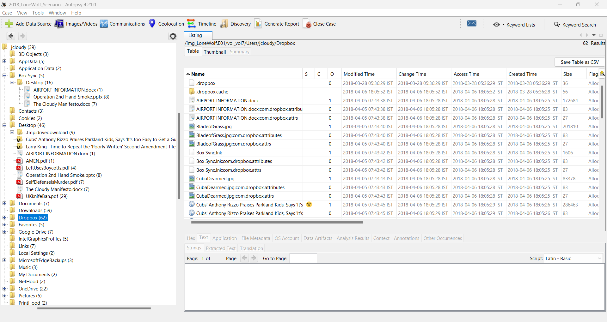Dropbox contents:

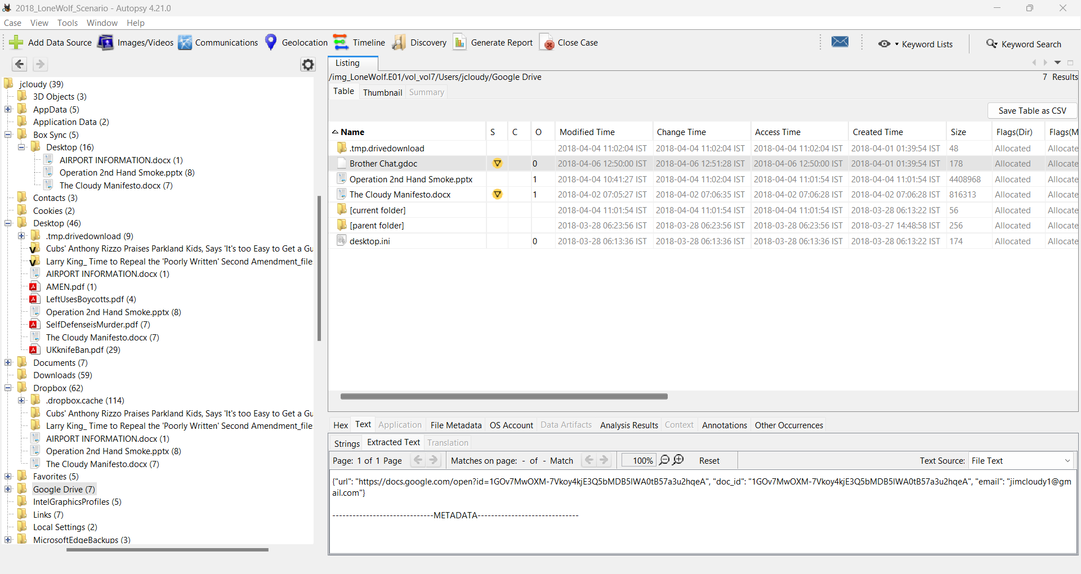Google Drive contents:

“Brother Chat.gdoc” file may be used as a chatting agent between him and his brother as he searched on google about “how to use google docs as chat” on 2018-03-30 09:05:31 IST

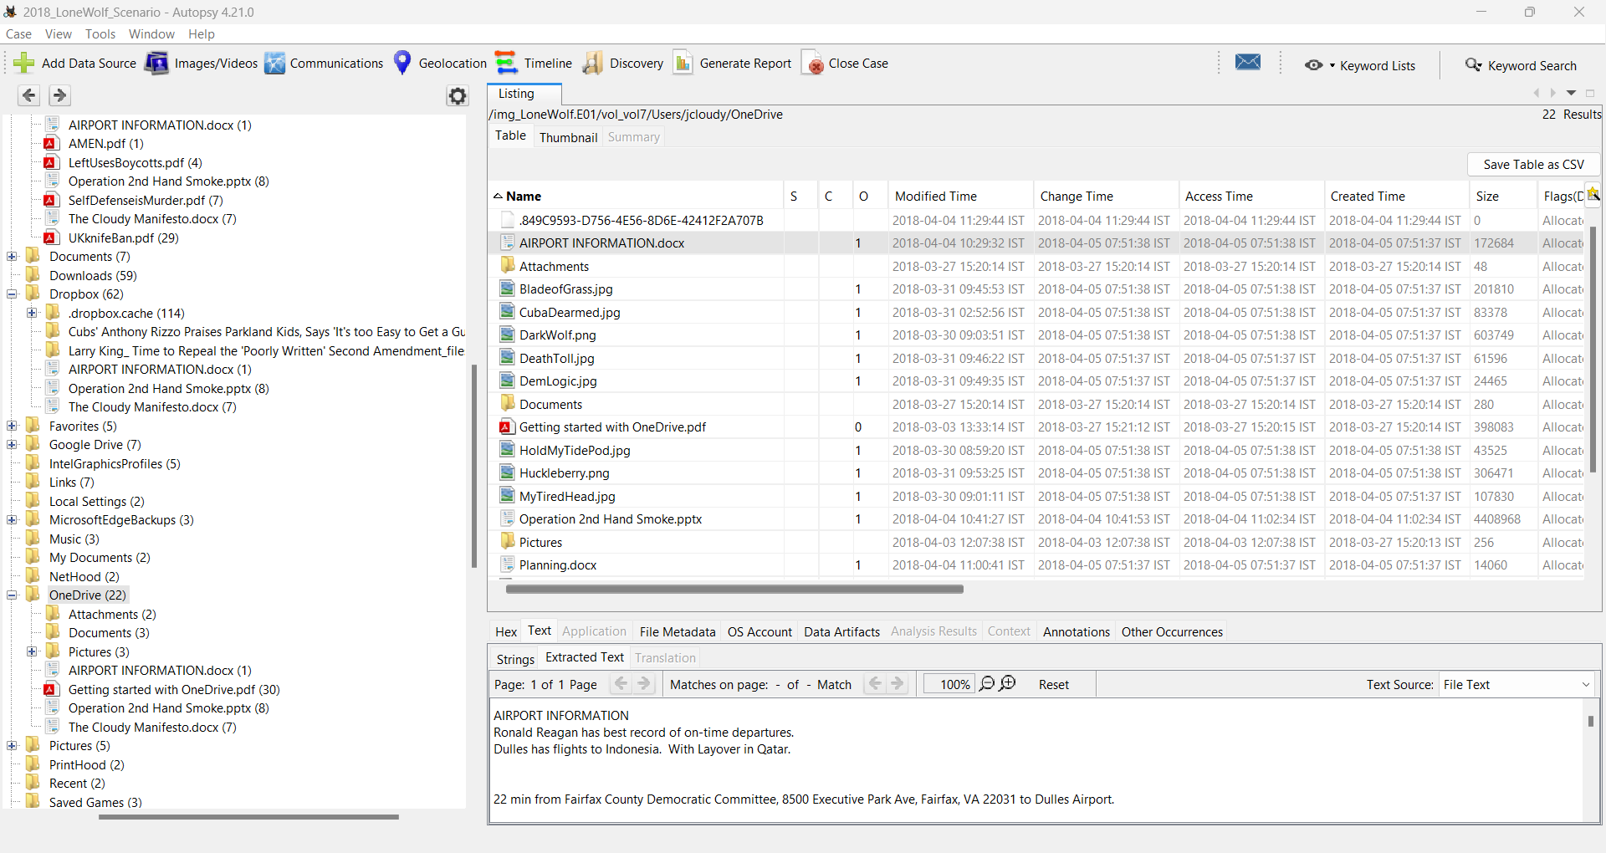OneDrive contents:

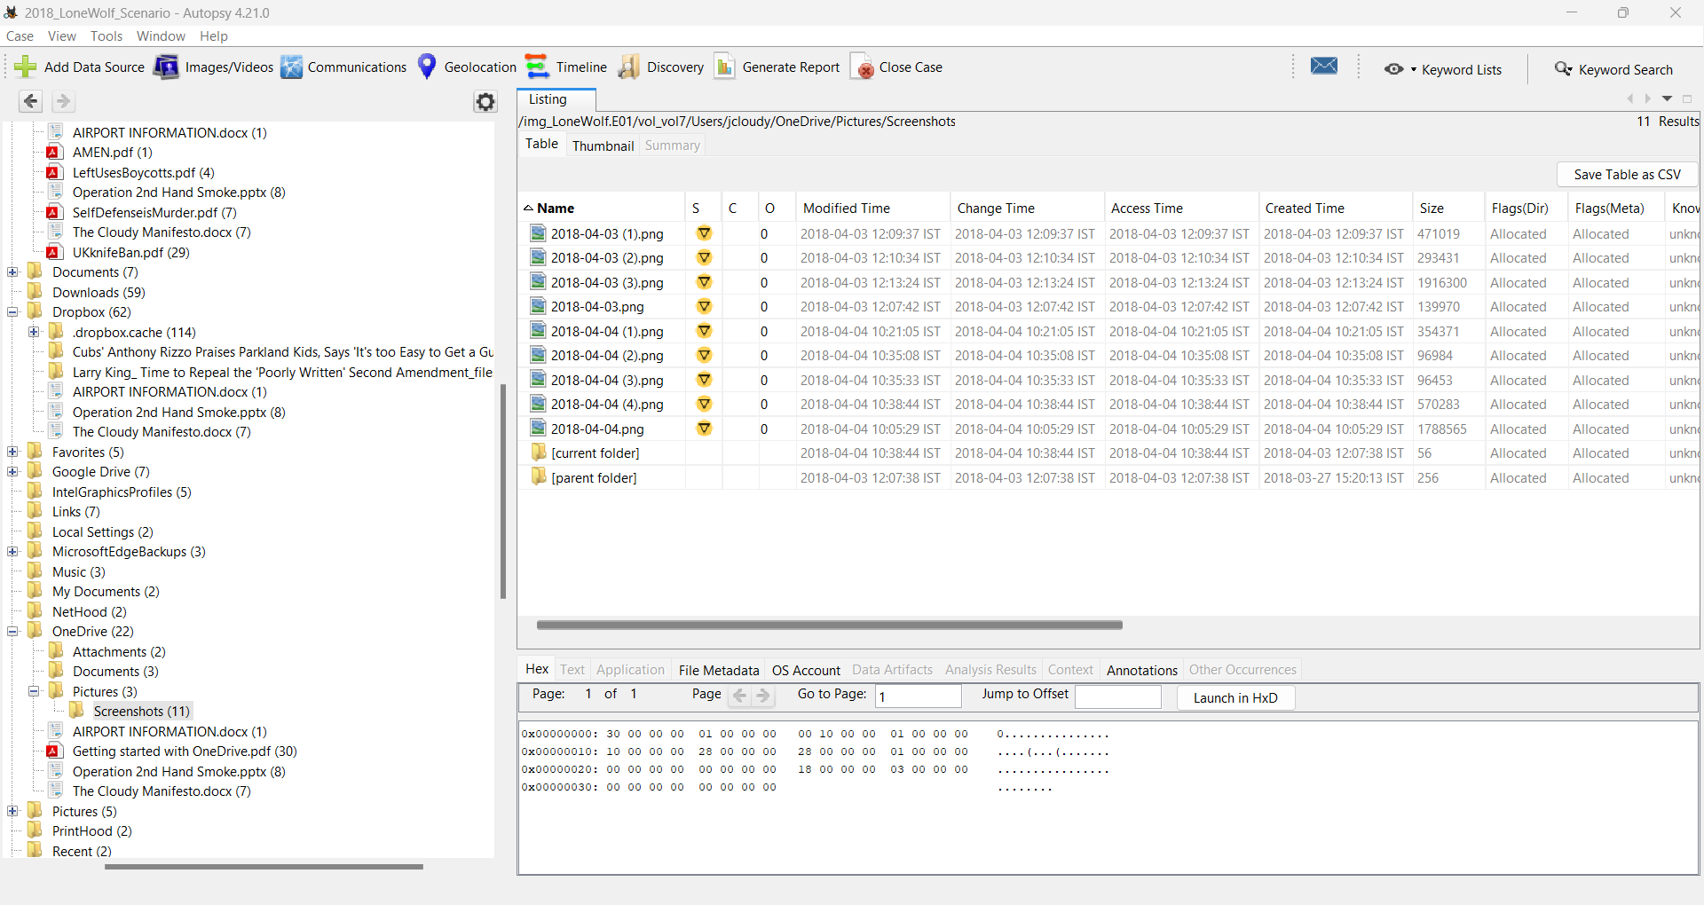

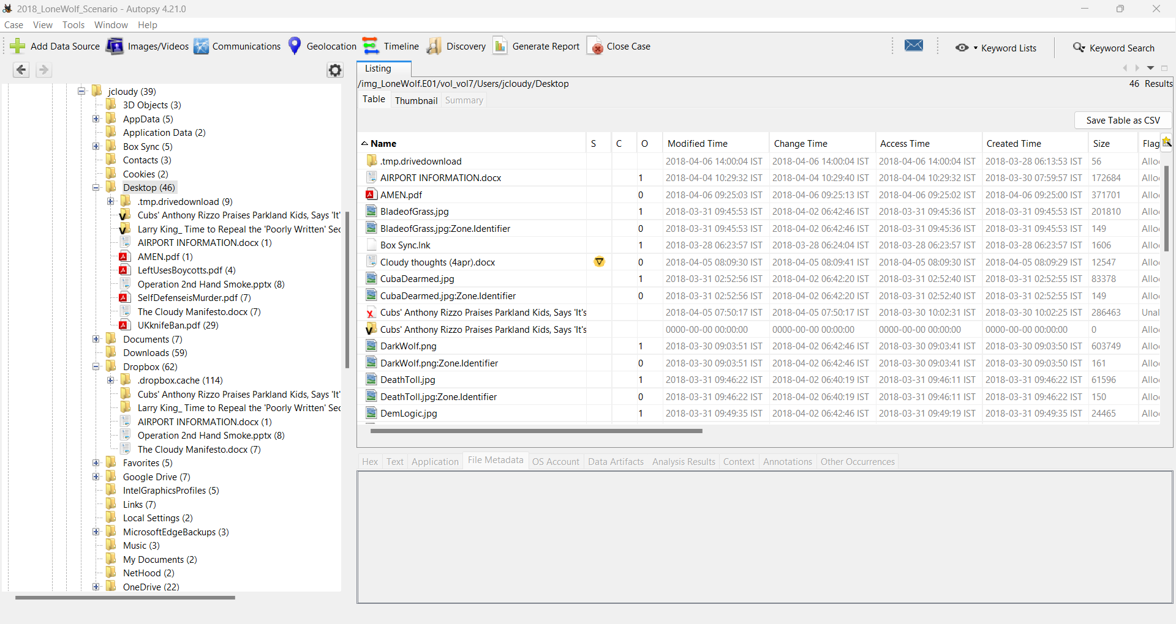Desktop contents:

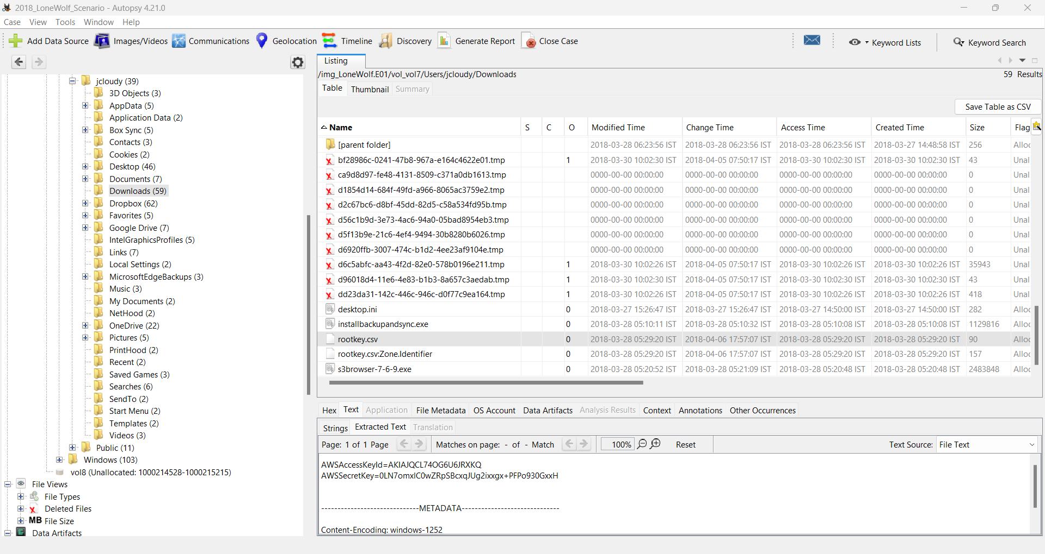Downloads contents:

“rootkey.csv” file contains AWSAccessKeyId and AWSSecretKey and it is of interest because Jimcloudy searched “amazon cloud storage”, “can i use amazon s3 for free”, “sync amazon s3 from desktop?” on 2018-03-28

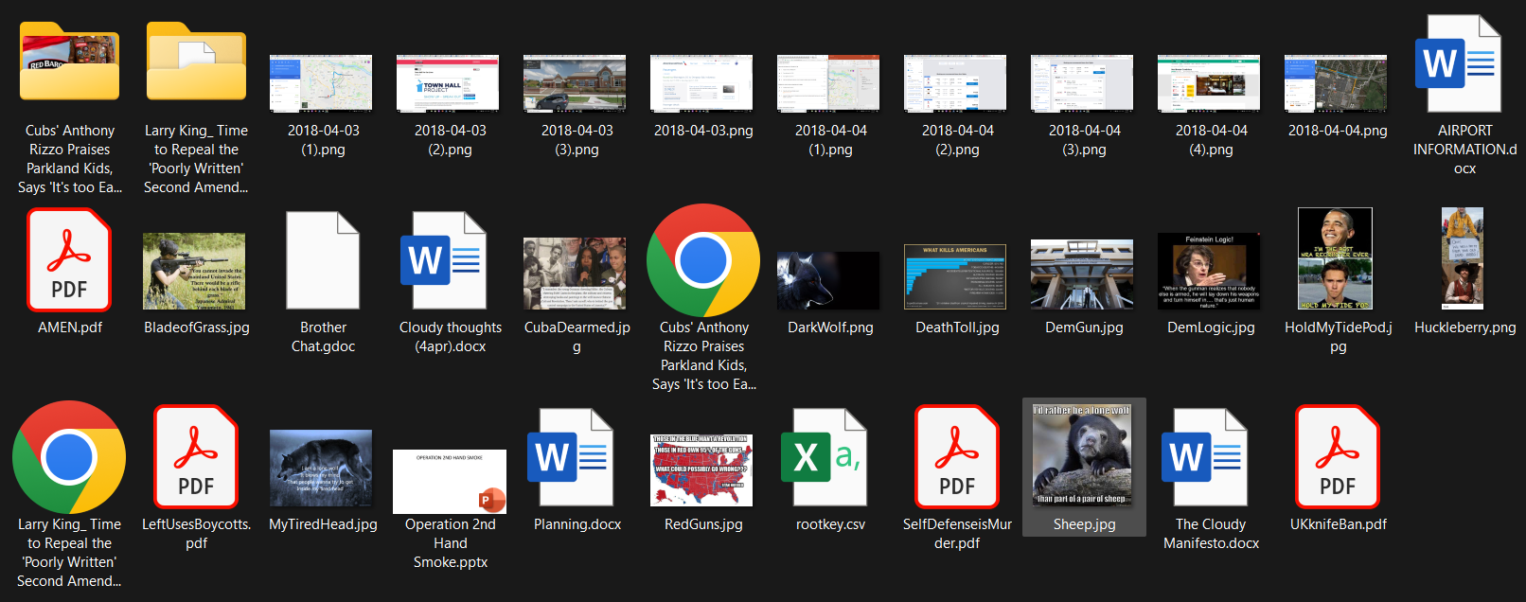From all of those folders I exported these files as evidence.

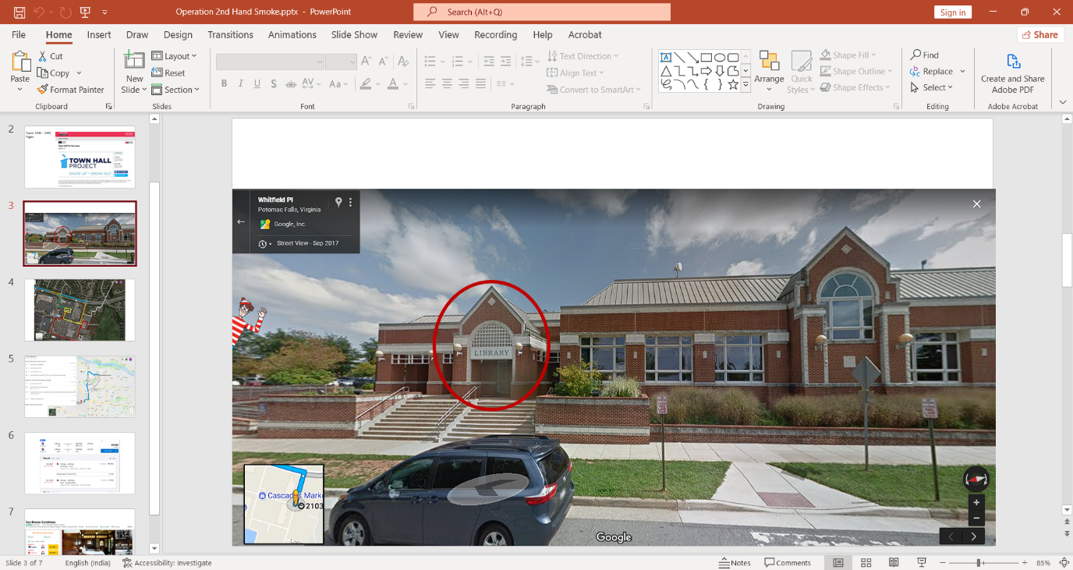Here are screenshots of some of the important evidence of mass shooting:

The Operation 2nd Hand Smoke PowerPoint indicates where the event should take place, the date and time of the event, the suspects destinations, and their departure to another country. Airport Information documents contains some text and screenshot to their destination. The planning document covers reveals their set up ideas before executing the operation. They contain their target, the supplies they are buying, escape route, and their thoughts process.

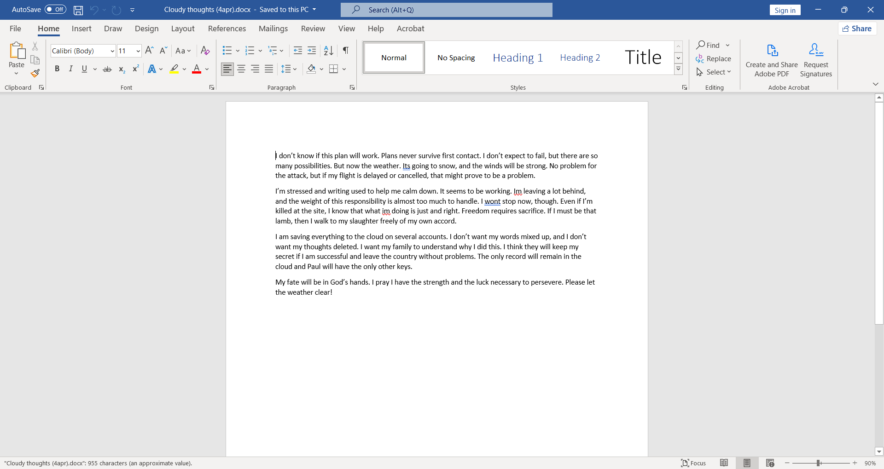The Cloudy thoughts (4apr) word document shows Jimcloudy’s thoughts on his plans.

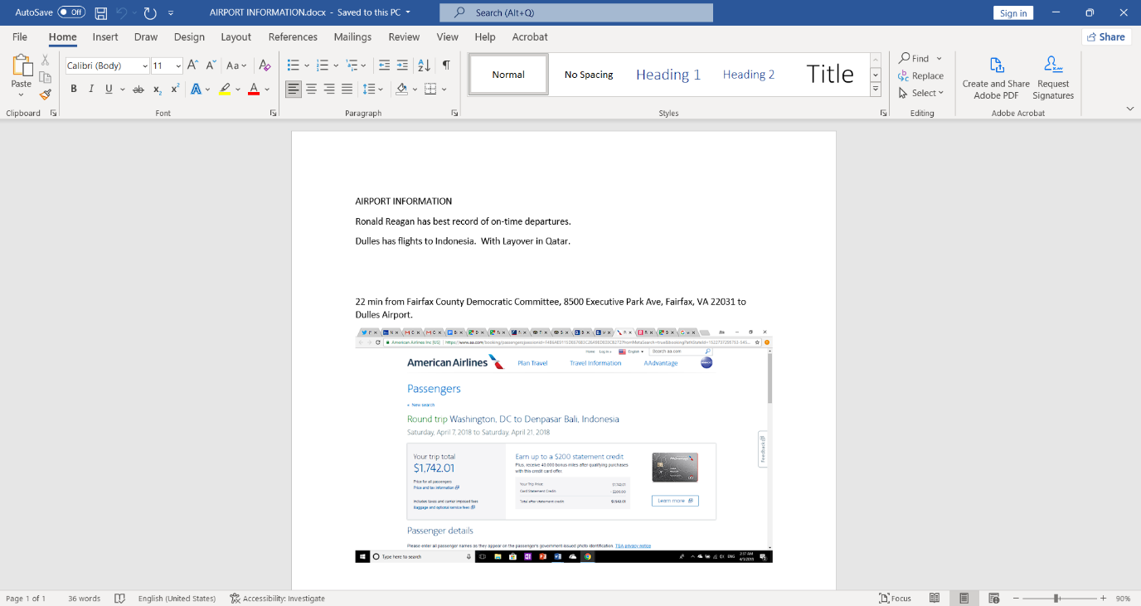The AIRPORT INFORMATION document shows the best records of a airports and flights to Indonesia.

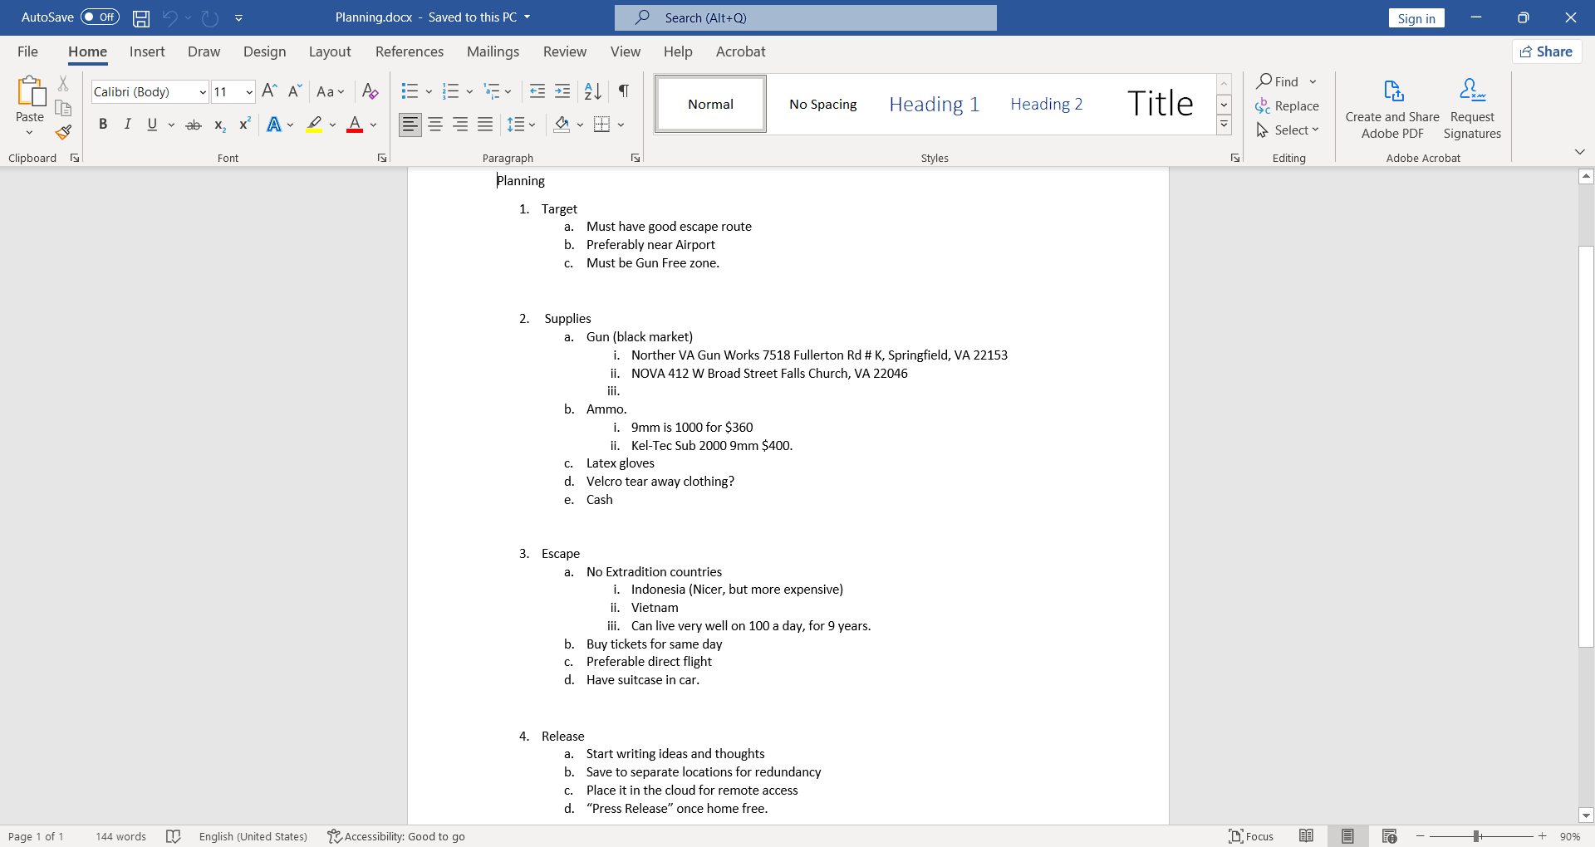

The Planning document has all the plans written in a short bullet point for target, supplies, escape and release.

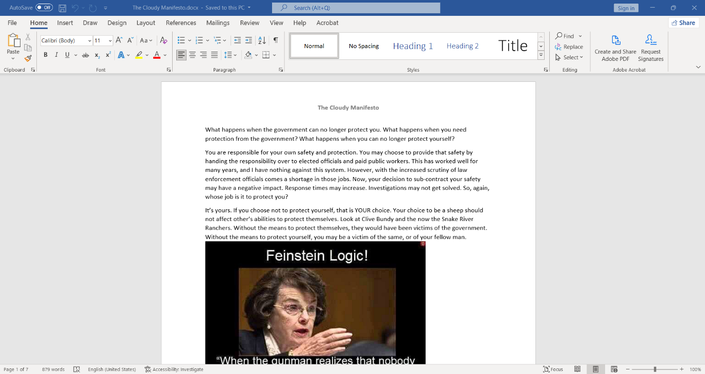The Cloudy Manifesto document has word written against the governments to brainwash the citizens of the America.

**2.3 ATTACK TIMELINE**

To establish a timeline on what happened on “Town Hall For Our Lives” event on Saturday, April 7, 2018 on 21030 Whitfield Place Sterling VA, 20165. Approximately between 12:30 PM and 1:00 PM, the suspect, Jimcloudy, will entered the building and start a mass shooting during that timeframe. The suspect will leave the library entrance after his plan is completed and headed to Dulles International Airport before police arrive at the crime scene. It will take 13 – 20 minutes to get to the destination. When the suspect will arrive at the Dulles International Airport, he will get his ticket via online few days prior before the mass shooting. The suspect’s destination will be Denpasar, Bali, Indonesia on April 8, 2018 after departing the United States for 22+ hours. Additionally, the suspect booked a lodging in Sea Breeze Candidasa, which is an hour and thirty minutes away from Denpasar, Bali, Indonesia.

**3 CONCLUSION & RECOMMENDATIONS:**

Importance of Disk Forensics are as follows:

* **Preservation of Evidence:** Digital forensics plays a crucial role in preserving evidence that can be used in court. The process of collecting and analyzing digital evidence is done in a way that ensures its integrity and authenticity, making it admissible in court. This helps in building a strong case and increases the chances of conviction.
* **Identification of Criminals:** Digital forensics can be used to identify the perpetrators of a crime. It can help in tracing the origin of a cyber-attack, identifying the source of a leak, and linking a suspect to a crime scene. This helps law enforcement agencies in their investigations and brings criminals to justice.
* **Protection of Corporate Interests:** Digital forensics can be used to protect the interests of corporations and organizations. It can help in identifying and preventing internal fraud, data breaches, and other cyber threats. This helps organizations in maintaining the confidentiality of their data and protecting their reputation.
* **Assisting in Cybercrime Investigations:** Digital forensics plays a vital role in investigating cybercrimes such as hacking, identity theft, and online fraud. It can help in tracing the origin of a cyber-attack and identifying the source of a leak. This helps law enforcement agencies in their investigations and brings cybercriminals to justice.
* **Facilitating Legal Proceedings:** Digital forensics can assist in legal proceedings by providing evidence that can be used in court. It can help in proving the authenticity of digital evidence and linking suspects to a crime scene. This helps in building a strong case and increases the chances of conviction.

To protect your laptop from digital forensic investigation, while it's crucial to respect legal boundaries and not engage in illegal activities, here are some general tips to safeguard your data and privacy:

* **Full Disk Encryption**: Use strong encryption software like BitLocker (Windows) or FileVault (Mac) to encrypt your entire hard drive. This makes it difficult for forensic investigators to access your files without your password.
* **Secure Boot and BIOS/UEFI Password**: Enable secure boot options in your BIOS or UEFI firmware settings. Set a strong password to prevent unauthorized access or modifications to your boot settings.
* **Use Virtual Machines (VMs)**: Work within a virtual machine environment (e.g., VirtualBox, VMware) for sensitive activities. VMs can be easily encrypted and deleted, leaving no trace on your physical machine.
* **Avoid Storing Sensitive Data Locally**: Whenever possible, store sensitive data on encrypted external drives or in secure cloud storage with strong encryption protocols.
* **Use Secure Communication Tools**: Employ end-to-end encrypted communication tools for sensitive conversations (e.g., Signal for messaging, ProtonMail for email).
* **Regularly Update Software**: Keep your operating system, applications, and security software up to date to protect against known vulnerabilities.
* **Securely Delete Files**: Use tools that securely delete files by overwriting them multiple times, making them harder to recover.
* **Disable Logging and Clear History**: Disable or limit logging and clear browser history, cookies, and caches regularly.
* **Physical Security**: Physically secure your laptop with a strong password, lock, or cable when not in use to prevent unauthorized access.
* **Legal Considerations**: Finally, ensure that all your actions comply with the laws and regulations of your jurisdiction. Engaging in illegal activities or attempting to obstruct a lawful investigation can have serious consequences.

Remember, while these measures can enhance your privacy and security, nothing is foolproof. It's essential to stay informed about evolving threats and security practices to adapt accordingly.

**4 LIST OF REFERENCES:**

<https://en.wikipedia.org/wiki/Digital_forensics>

<https://www.youtube.com/watch?v=ifRoOMKRjas&t=874s>

<https://www.youtube.com/watch?v=wpev6WdnvEU>

<https://www.autopsy.com/>

<https://www.cybernx.com/b-5-benefits-of-digital-forensics>

<https://medium.com/@tusharcool118/autopsy-tutorial-for-digital-forensics-707ea5d5994d>

<https://www.geeksforgeeks.org/analysis-of-data-source-using-autopsy/>